**Spring Boot**

* Before spring boot came into picture it difficult to define configurations in web.xml, for dependency injection we needed to add it in pom.xml, spring beans were managed in context.xml and plus we needed to add more non-functional features to application like logger, server configuration etc which made application creation a little bit difficult.
* Spring 3.0 requires JDK 17.
* <https://start.spring.io/> : Spring initializer.
* src/main/java 🡪 Where we will have our Java code.
* src/main/resources 🡪 Where we will have our application configurations.
* src/test/java 🡪 Where we will keep our test case.

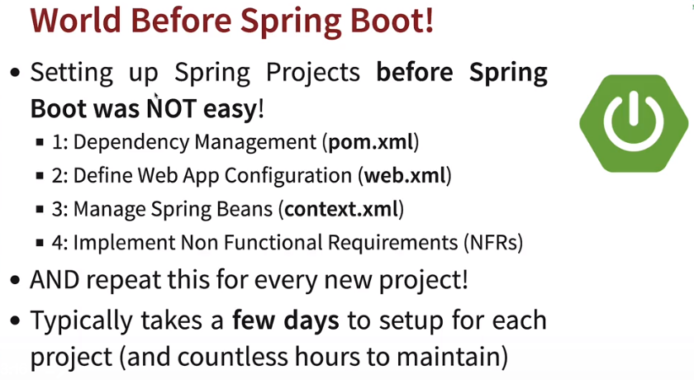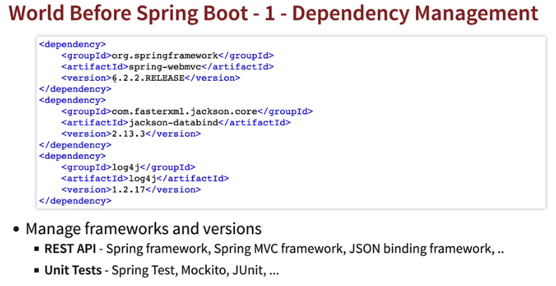

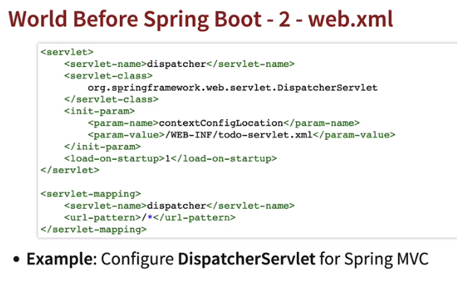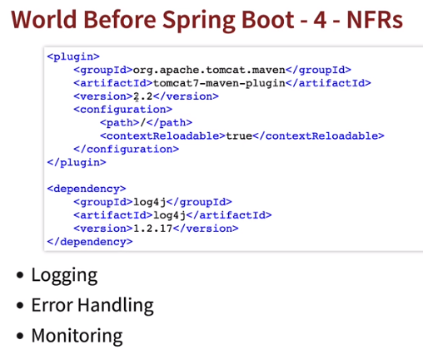

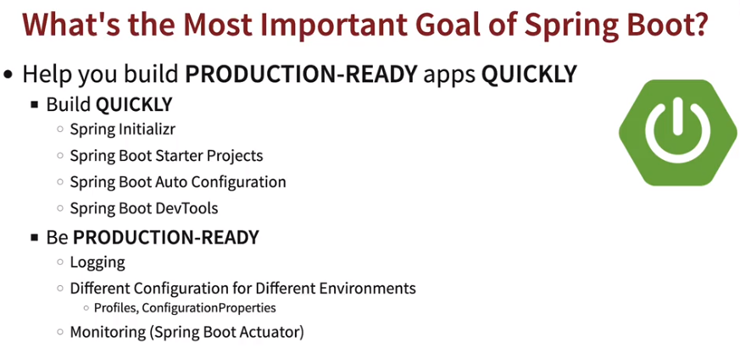

* **Spring Boot Starter Web:** Spring boot starter web brings number of dependencies for the type of application we’re building like webapp, RestAPI etc it adds dependencies for running tomcat, converting responses to JSON, Spring Web and Spring Web MVC and we don’t need to manually configure all dependencies in pom.xml.

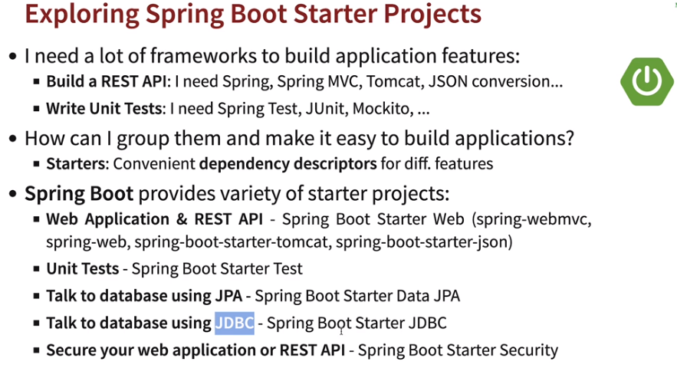

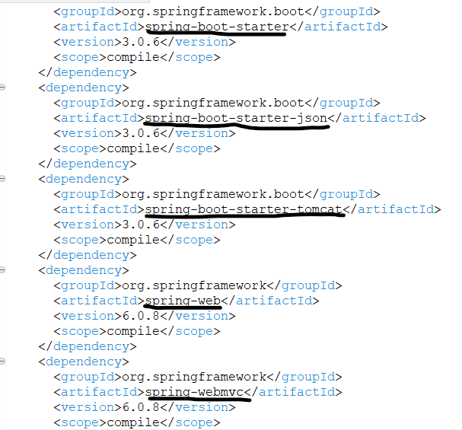

* **Spring Auto Configuration:** Spring auto configurations provides automated configuration for your application. These configurations are added based on the frameworks in the class path.
  + Ex: DispatcherServletAutoConfiguration added when we add @RestController. Based on dependencies added Spring boot finds positive matches and negative matches of dependencies and then adds them into application. spring-boot-autoconfigure jar takes care of adding required dependencies inside application. JacksonHTTPMessageConverter converts beans to JSON format automatically.



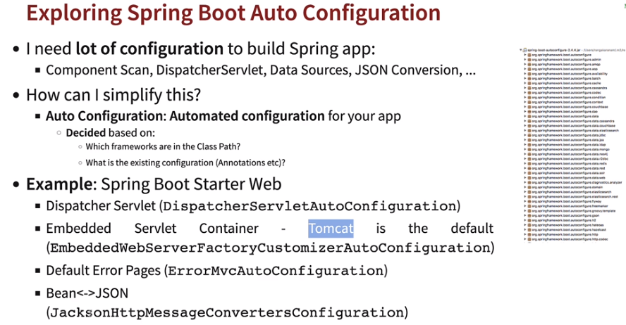

* **Spring Boot Dev Tools:** Spring Dev Tools provides Developers with feature to make changes in code and automatically restart application, we don’t need to manually restart application. It will not pickup changes in the pom.xml file, only in properties or Java files.

*<dependency>*

*<groupId>org.springframework.boot</groupId>*

*<artifactId>spring-boot-devtools</artifactId>*

*</dependency>*

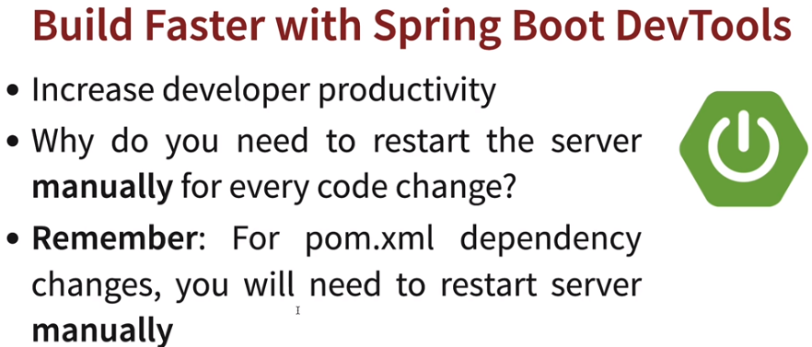

* **Creating simple RestAPI:** 
  + Create a simple controller class, which will handle the requests. Specify class with *@RestController* annotation and create mapping url using *@RequestMapping(“<url>”)*

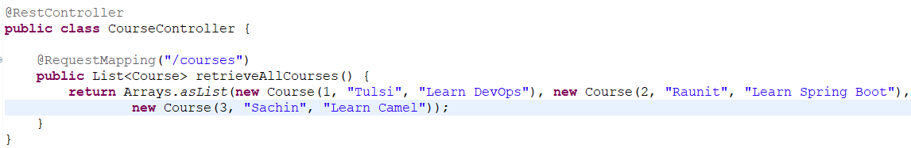

* + Create a bean class with variables, which will be used to map requests/responses.

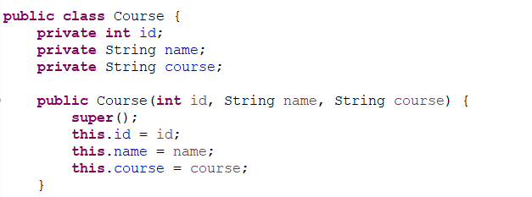

* **@RestController:** This annotation is used to create RESTful web services using Spring. This annotation takes care of mapping request data to the defined request handler method. Once response body is generated from the handler method, it converts it to JSON or XML response.
* **@RequestMapping:** It is used to map web requests onto specific handler classes and/or handler methods.
* **Logging Levels:** If we select trace, then it will print errors combining below levels of logging like Trace = Debug+Info+Warn+Error+Fatal+Off, Debug = Info+Warn+Error+Fatal+Off and so on.

|  |  |  |
| --- | --- | --- |
| **Level** | **Value** | **Description** |
| OFF | 0 | No logging |
| FATAL | 100 | The application is unusable. Action needs to be taken immediately. |
| ERROR | 200 | An error occurred in the application. |
| WARN | 300 | Something unexpected—though not necessarily an error—happened and needs to be watched. |
| INFO | 400 | A normal, expected, relevant event happened. |
| DEBUG | 500 | Used for debugging purposes |
| TRACE | 600 | Used for debugging purposes—includes the most detailed information |

* **Profiles:** Each application has different environments in general DEV, QA, PROD etc. Spring provides a way to segregate parts of your application configuration and make it only available in certain environments.
  + ***spring.profiles.active=<ENV>:***Addin application.properties and create properties for each environment application-dev/application-prod etc. Based on active profile set in application.properties it will give priority to set env properties file.

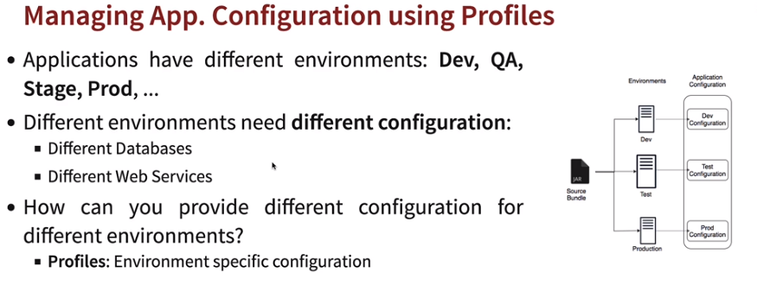

* **@ConfigurationProperties(prefix = “<prop_pre>”):** It is an annotation to bind our configuration properties and used with *@Component* so that spring can scan and map properties from application.properties.

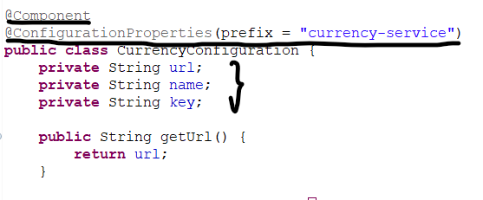 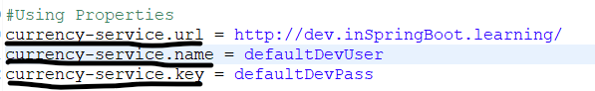

* **Deploying Java applications:** Earlier deploying Java applications was complex process (WAR approach 🡪 Install Java, convert to WAR, install on Websphere, tomcat etc). Now we need to convert our Java application in JAR files and it contains tomcat within JAR files to run which makes it easier to run our applications.

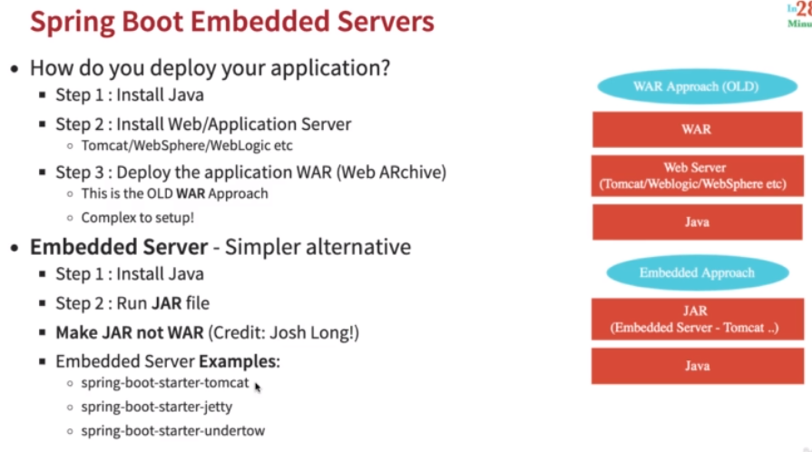

* Convert application to JAR file using Maven Build 🡪 *clean install*.
* Go to JAR file location and *java -jar <JAR_Name>.jar* 🡪 Launches application.
* **Spring boot Actuator:** Spring Boot Actuator: Monitor and manage your application in your production. It provides a number of endpoints: 1) beans - Complete list of Spring beans in your app 2) health - Application health information 3) metrics - Application metrics 4) mappings - Details around Request Mappings. Add below dependency to enable actuator.

*<dependency>*

*<groupId>org.springframework.boot</groupId>*

*<artifactId>spring-boot-starter-actuator</artifactId>*

*</dependency>*

* **Link to get actuator:** *http://<host>:<port>/actuator*

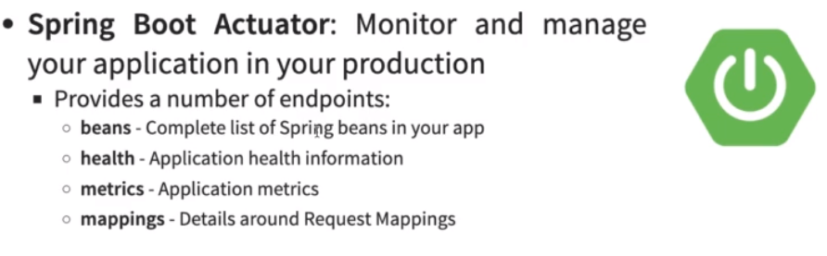

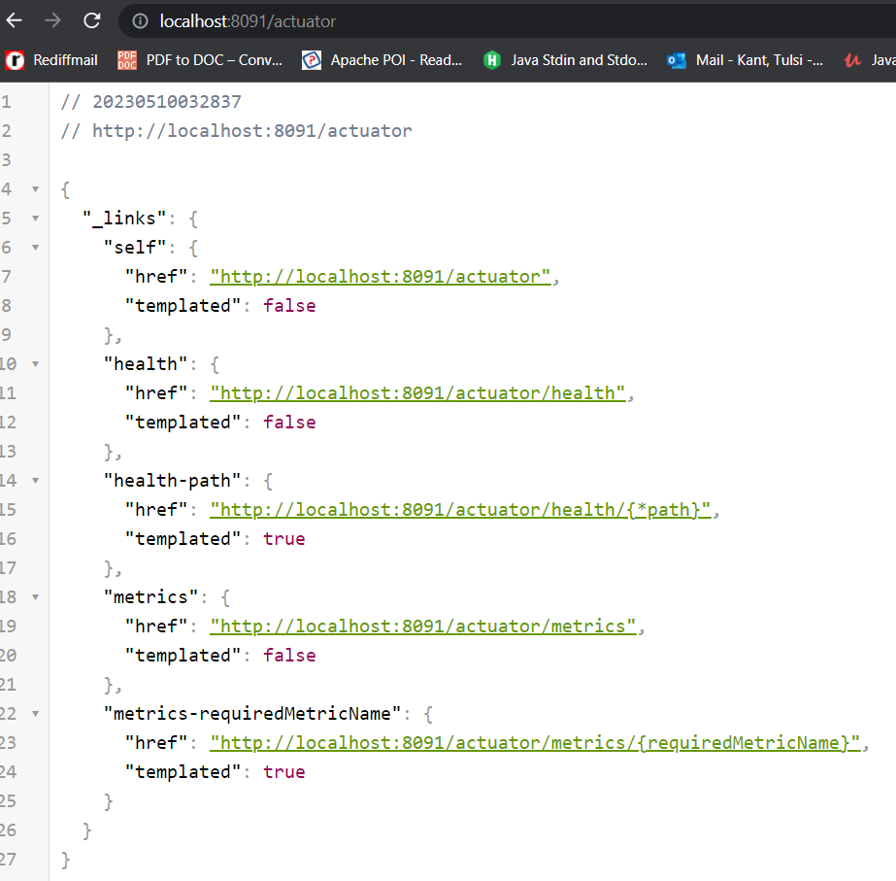

* **Actuator Enable all:**

*management.endpoints.web.exposure.include=\**

* **Spring vs Spring MVC vs Spring Boot:** 
  + Spring apps need a lot of configuration - Component Scan, DispatcherServlet, Data Sources, JSON Conversion, etc. Spring Boot Auto Configuration provides automated configuration for your app based on 1) Which frameworks are in the Class Path? 2) What is the existing configuration (Annotations etc)?
  + *Spring MVC* is used to build web applications in decoupled approach where we need to configure lot of things like DispatcherServlet, ModelView and View Resolver.
  + *Spring Boot* makes it easy to build production ready applications quickly using starter projects, auto configuration and production application features like monitoring, tracing, embedded servers and default error handling.
  + Goal of Spring Boot is to help you build PRODUCTION-READY apps QUICKLY. 1) Features that help you build QUICKLY - Spring Initializr, Spring Boot Starter Projects, Spring Boot Auto Configuration, Spring Boot DevTools 2) Features that help you be PRODUCTION-READY - Logging, Profiles, ConfigurationProperties, Monitoring (Spring Boot Actuator)
  + ***@SpringBootApplication:*** Itis a combination of *@SpringBootConfiguration @EnableAutoConfiguration @ComponentScan* public *@interface SpringBootApplication.*

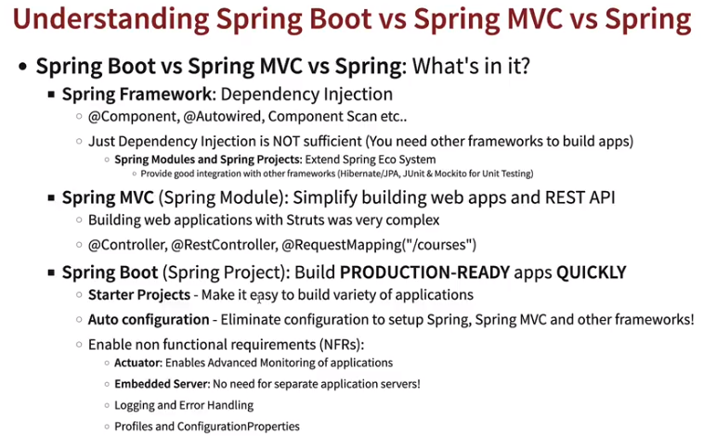

* **JDBC vs Spring JDBC:** In simple JDBC we needed to write more code for connection, query etc. In Spring JDBC we can use functions to query database.

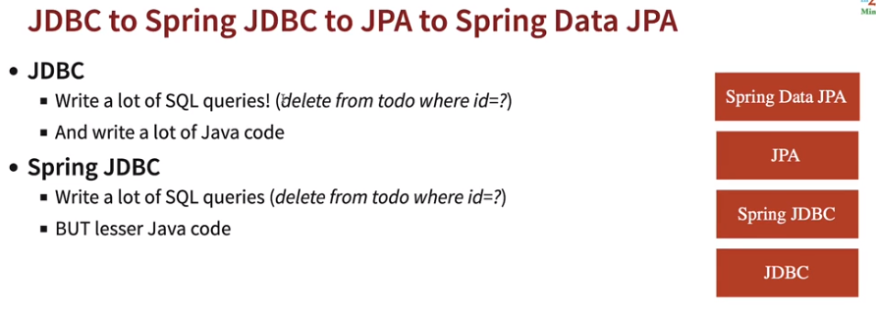

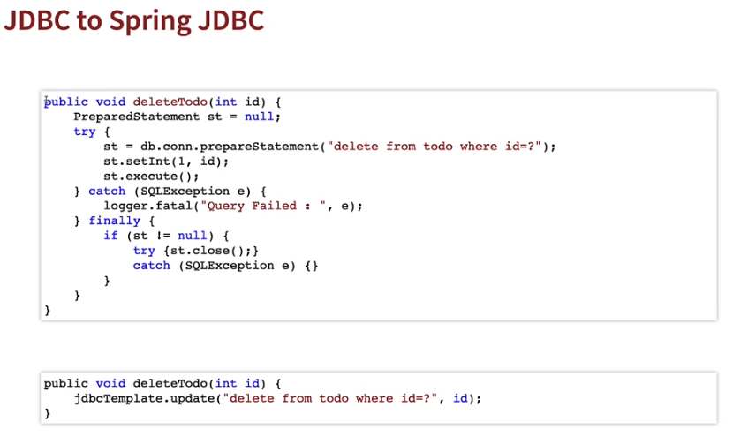

* **@Repository:** This annotation is used to indicate that the class provides the mechanism for storage, retrieval, search, update and delete operation on objects. Generally, used to annotate classes that connect with Databases.
* **CommandLineRunner:** Command Line Runner interfaces lets you to execute the code after the Spring Boot application is started. It can be used to perform any actions immediately after the application has started. Generally, used to execute some start JDBC queries.
  + In the below example we used interface *CommandLineRunner* to execute a query when Spring Boot application is started. Add @*Component* and @*Autowire* *JDBCRepository* class.
  + *JDBCRepository* class is represented with @*Repository.* Create a method to insert rows using custom query. Add @*Autowire* *JdbcTemplate*, which allows us to use Spring JDBC methods.
  + *<Repo>.update(<query>)* 🡪 Used to run insert, update, delete query.
  + *<Repo>.queryForObject(<query>, new BeanPropertyRowMapper<>(<Bean>.class), <param>) 🡪* Used to query database and return result.
  + *new BeanPropertyRowMapper<>(<Bean>.class) 🡪* Repository will query database, the resultset returned will be mapped to Bean class to return result in format or use *rowMapper.*

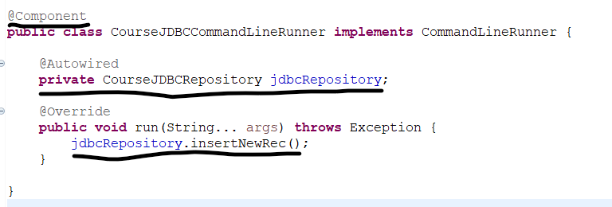

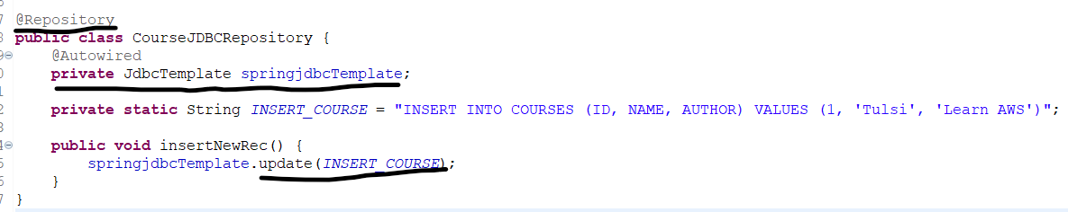

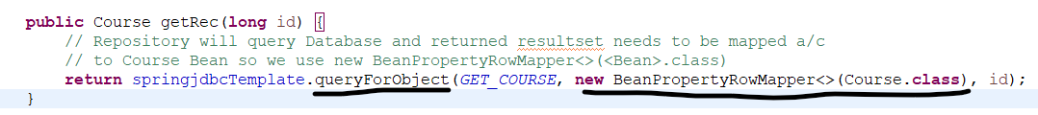

* **JPA:** In Spring JDBC we needed to write lot of queries, to address this JPA addresses Java objects (model class) to map with the databases.
* If we’re using h2 inbuilt memory database, based on object mapped it will automatically create table and column.
  + **@Entity:** Maps Java object with your DB.
  + **@Id:** Annotating field is a Primary key for the table.
  + **@GeneratedValue:** Auto generate values for the field.
  + **@Column:** Annotating field is a column for the table.
  + ***@Transactional:*** It is used indicate that a transaction is required to execute this method.
  + ***@PersistenceContext:*** The persistence context is the first-level cache where all the entities are fetched from the database or saved to the database.
  + **EntityManager**: The EntityManager API is used to create and remove persistent entity instances, to find entities by their primary key, and query over entities.

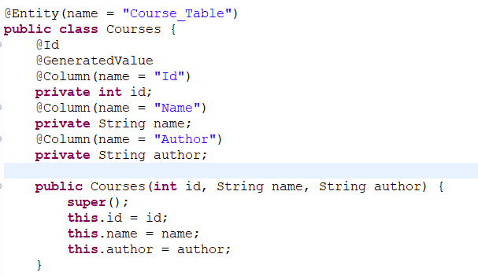 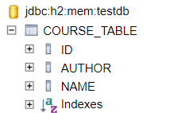

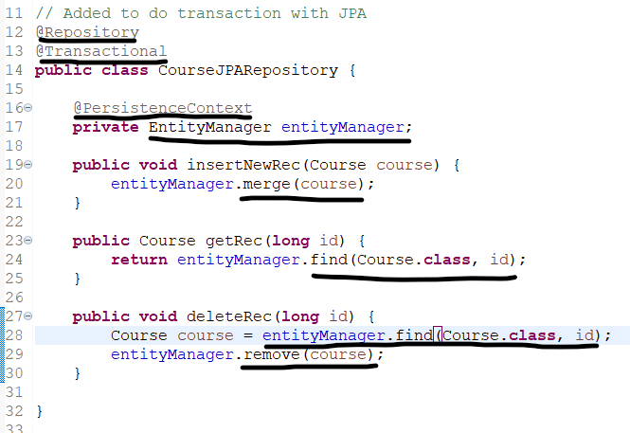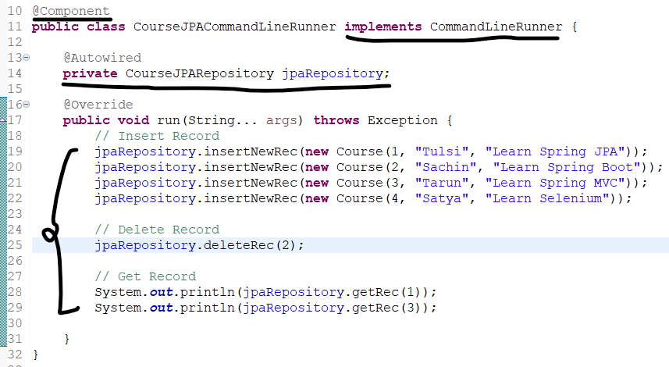

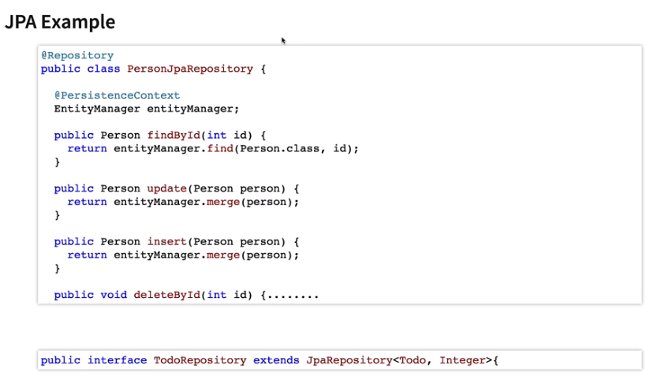

***#Show JPA queries:***

*spring.jpa.show-sql=true*

* **Spring Data JPA:** In Spring Data JPA we don’t need have entityManager to be used for transactions with database. It directly maps with Java object with database table. All we need to is *create a repository interface and extend with JpaRepository<’bean_class’, ‘id_type’>.*
  + **save(<bean>):** Used to insert new record.
  + **deleteById(<id>):** Used to delete record by primary key.
  + **findById(<id>):** Used to retrieve data by primary key.
  + **count():**Gets total rows count.
  + **findAll():**Gets all records in a table.

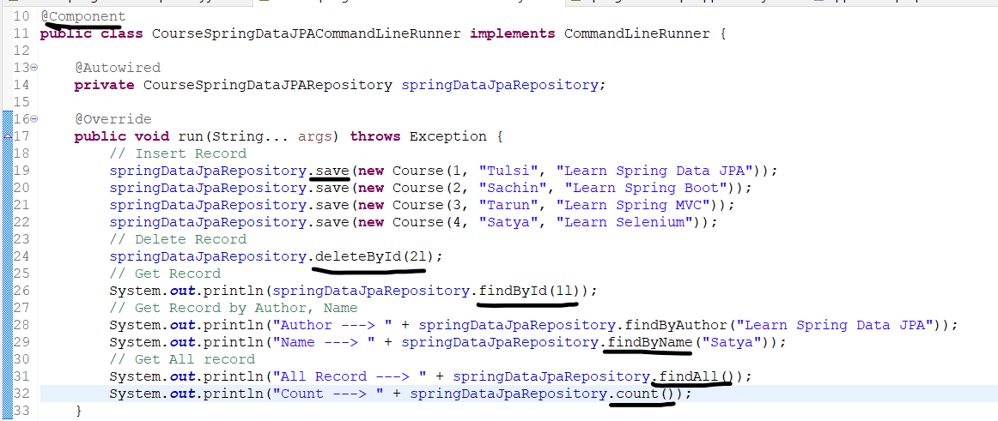

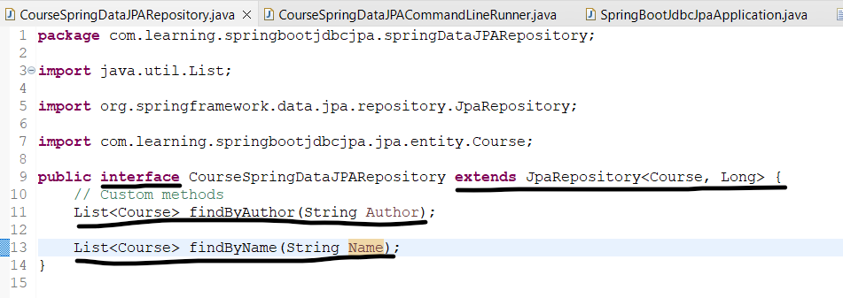

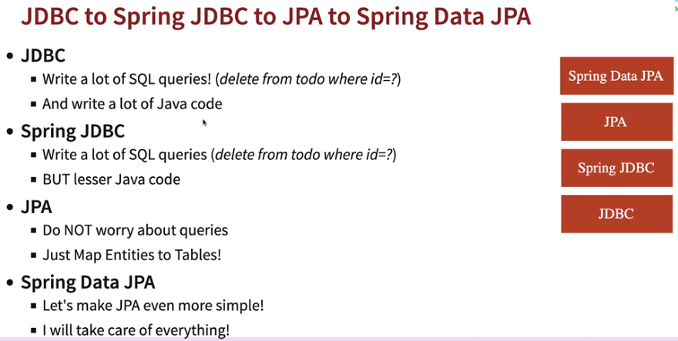

* **Hibernate vs JPA:** JPA is an API which define entities, manages them and map attributes like id, column etc. Hibernate is an implementation over JPA. Hibernate is not recommended though.

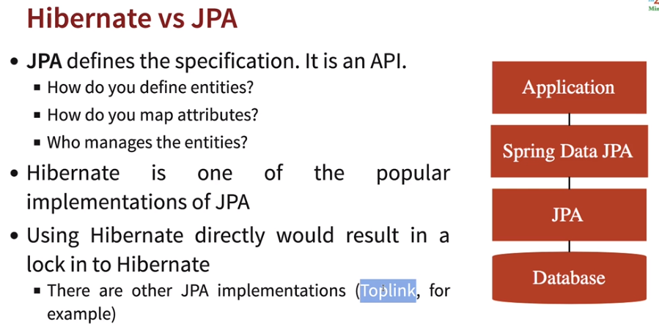

***Webapplication***

* ***@ResponseBody:*** It returns the value as JSON to the webpage. It tells a controller that the object returned is automatically serialized into JSON and passed back into the HttpResponse object. If we need to redirect to some JSP don’t need *@ResponseBody.*
* ***@Controller:*** It indicates that a particular class serves the role of a controller.
  + *@Controller* is used to create web controllers that return views, which is further resolved by view resolver, while *@RestController* is used to create web services that return JSON or XML data
* ***@RequestParam:*** This binds the request parameter or values passed in url with the variable.
* **tomcat-embed-jasper:** provides support for . jsp file rendering. Add below in pom.xml.

*<dependency>*

*<groupId>org.apache.tomcat.embed</groupId>*

*<artifactId>tomcat-embed-jasper</artifactId>*

*<scope>provided</scope>*

*</dependency>*

* **JSP folder location**: Spring provides the standard JSP location 🡪 *src/main/resources/META-INF/resources/WEB-INF/jsp/<JSP_name>.jsp*. Spring is aware of location of JSP *src/main/resources/META-INF/resources,* then we need to type as suffix and prefix in application.properties.

*spring.mvc.view.prefix=/WEB-INF/jsp/*

*spring.mvc.view.suffix=.jsp*

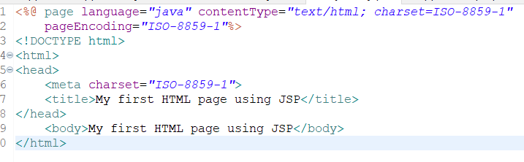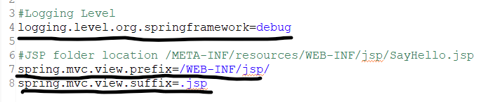

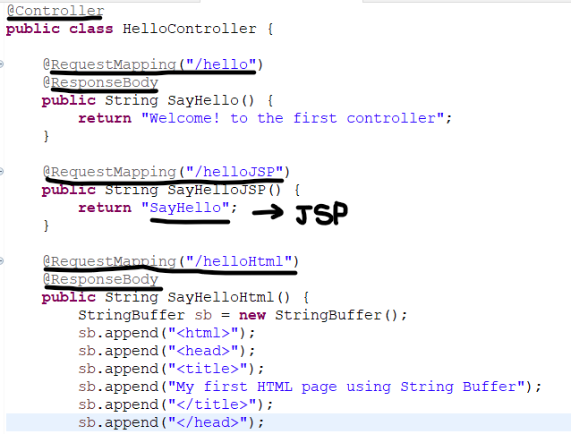

* Browser send *HTTPRequest* to the server when we hit the link, the server handles the request incoming and returns the response *HTTPResponse*.

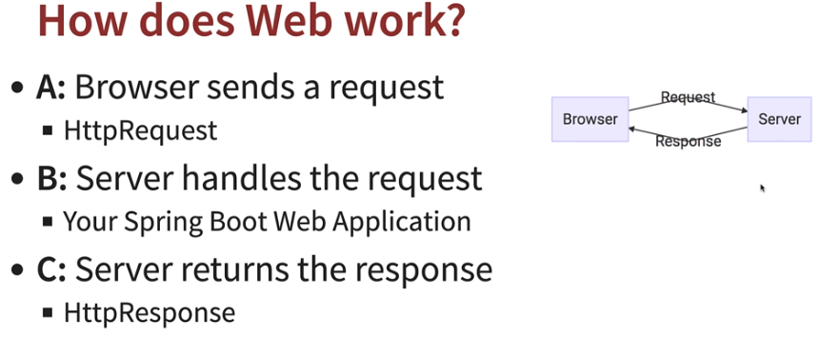

* **ModelMap:** Whenever we want to pass variable value from Controller to JSP (View), Model comes into picture. When we put any variable in Controller *ModelMap* that value can be accessed in *JSP* via *${<var>}* expression language.

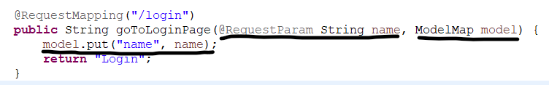

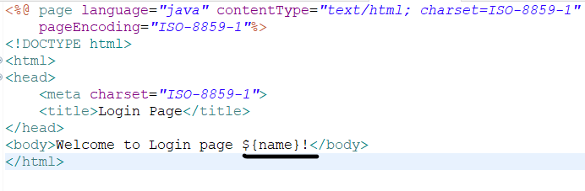

* **Logging/Sl4j:** *logging.level.<package_name>=<logging_level>.* Ex: *logging.level.org.com.learning.webapplication=INFO.*
  + Add loggerfactory *🡪 private Logger <name> = LoggerFactory.getLogger(getClass());*
  + Use *<name>.<level>(“<msp> {}”, var)* in class.
  + Sl4j is default logging framework provided by Spring Framework.

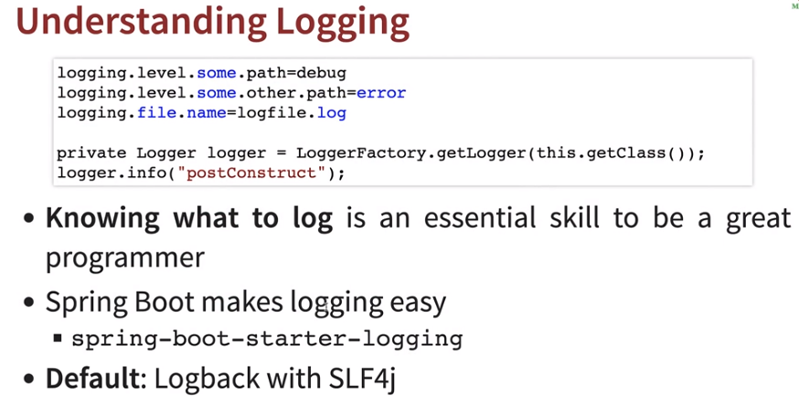

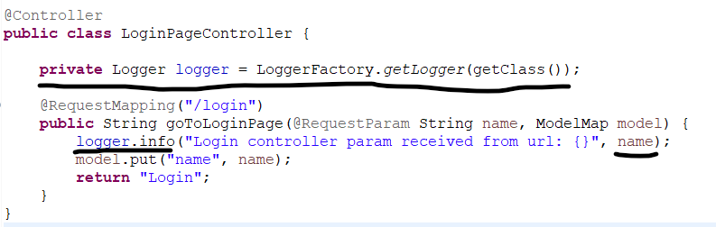

* **WebApplication architectures:** 
  + ***Model 1:*** In model 1 architecture all the code and redirects were written in the JSP itself. Coding was tough.

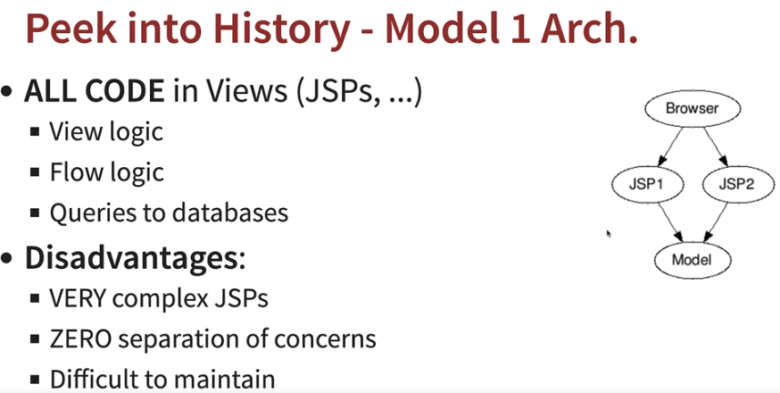

* + ***Model 2:*** In model 2 MVC concept came (model, view and controller).
    - ***Model:*** Data to generate the view.
    - ***View:*** Show the information to user.
    - ***Controller:*** Controls the flow.

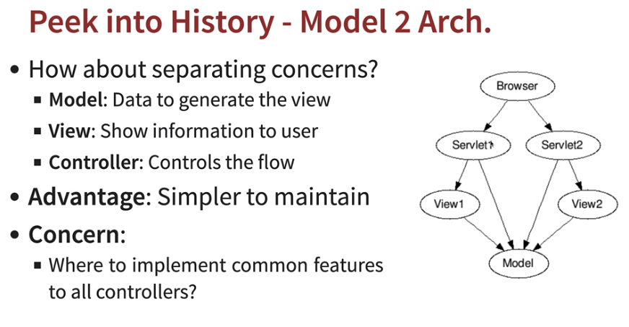

* + ***Flow Controller:*** Flow controller came into picture since in MVC if one controller needed to use the already existing feature in other controller, it was difficult. Like auth will be used in every controller. Flow controller will redirect the flow to servlet/view depending on the request came.

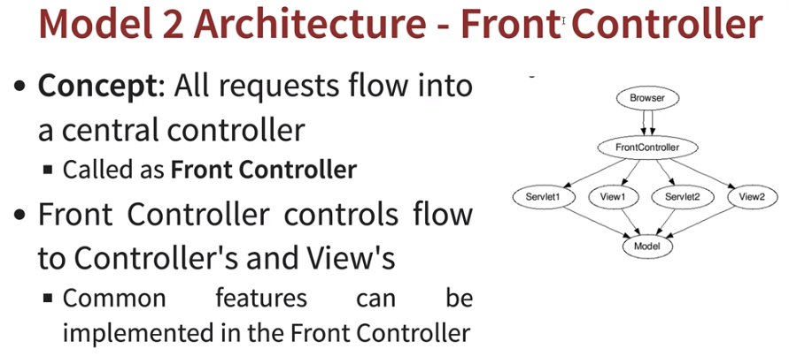

* + ***Spring MVC Dispatcher Servlet:*** Dispatcher servlet is implementation of above front controller.
    - *It receives HTTP request.*
    - *Processes HTTP request: Identifies correct controller, executes controller method, identifies view and executes view.*
    - *Returns HTTP response.*

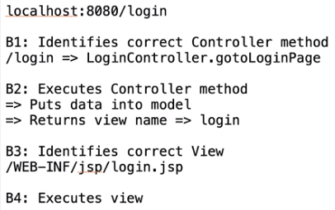

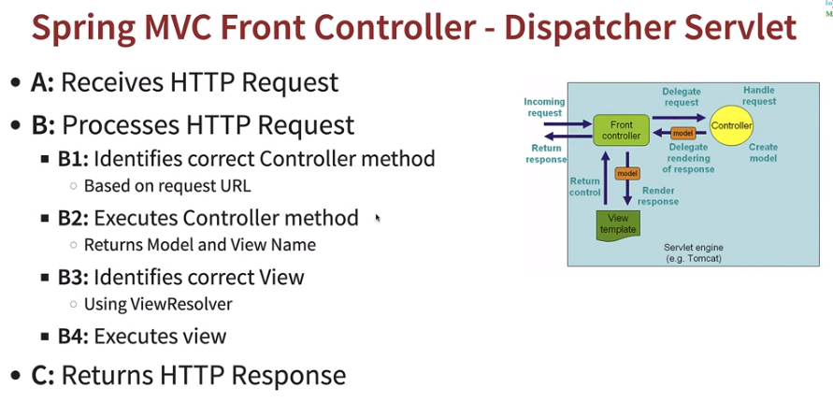

* ***POST:*** *<form>* is used to take input values from user. Whenever we are sending data from view/jsp it is recommended to use POST method as the input values entered will be passed in url if *<form type=”post”>* is not added.
* ***HTTP Request Method:*** If we don’t define HTTP Request methods in the RequestMapping then application will handle both get/post method on same page and will not redirect to new page. Hence, we need to segregate RequestMapping for each pages to handle different request methods types.
  + *@RequestMapping(value=”<url>”, method=RequestMethod.<type>)*

|  |
| --- |
| **Method and Description** |
| **GET**  The GET method is used to retrieve information from the given server using a given URI. Requests using GET should only retrieve data and should have no other effect on the data. |
| **HEAD**  Same as GET, but transfers the status line and header section only. |
| **POST**  A POST request is used to send data to the server, for example, customer information, file upload, etc. using HTML forms. |
| **PUT**  Replaces all current representations of the target resource with the uploaded content. |
| **DELETE**  Removes all current representations of the target resource given by a URI. |
| **CONNECT**  Establishes a tunnel to the server identified by a given URI. |
| **OPTIONS**  Describes the communication options for the target resource. |
| **TRACE**  Performs a message loop-back test along the path to the target resource. |

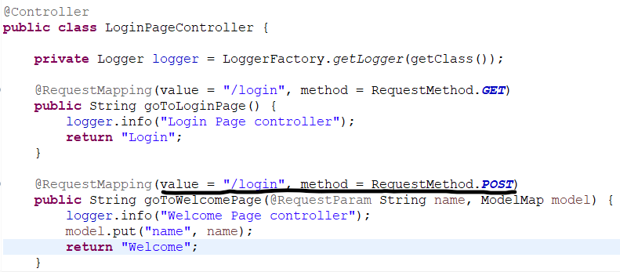

* ***@Service:*** Same as *@Component(bean to be managed by spring)* but is used to represent some business logic implementation.

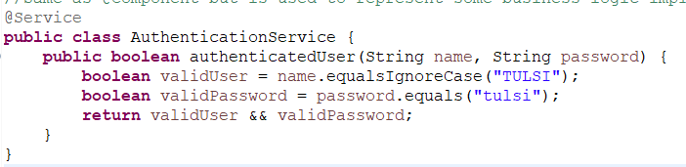

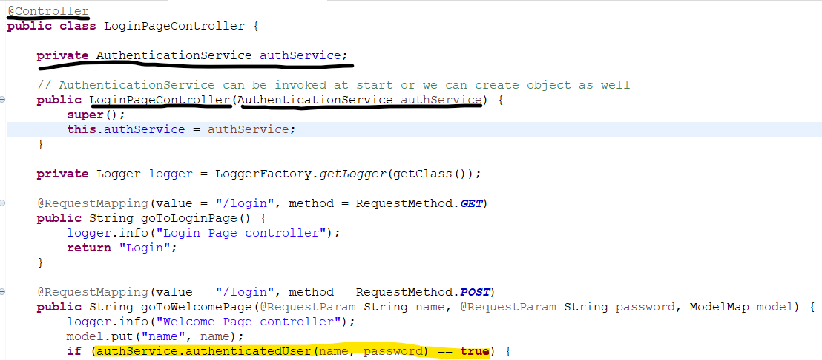

* ***Request vs Session:*** Requests stored the variable values till the page is rendered, but if we navigate to some other page the values is not retained. In case we need any variable values to be retained across we need to use the *@SessionAttributes* across the controller which needs the values. Ex: *@SessionAttributes(“<var>”).*

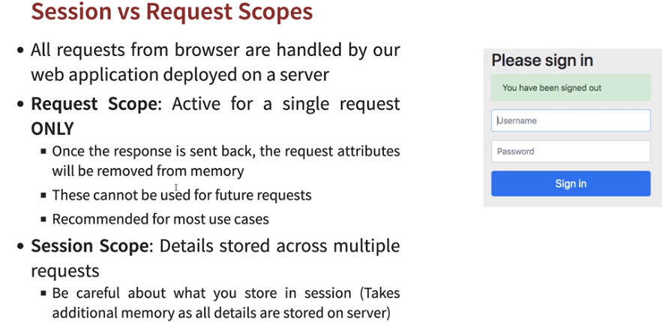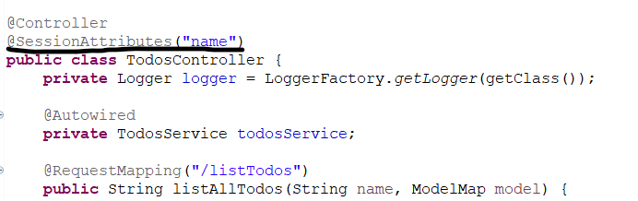

* ***JSTL:*** JSTL stands for JSP Standard Tag Library. JSTL is the standard tag library that provides tags to control the JSP page behavior. JSTL tags can be used for iteration and control statements, internationalization, SQL, dynamic data rendering etc.
  + Add below dependencies for JSTL dependency and in JSP add tag library.
  + *<%@ taglib uri="http://java.sun.com/jsp/jstl/core" prefix="c" %>*

***<!--JSTL dependencies JSTL API and JSTL implementation-->***

*<dependency>*

*<groupId>jakarta.servlet.jsp.jstl</groupId>*

*<artifactId>jakarta.servlet.jsp.jstl-api</artifactId>*

*</dependency>*

*<dependency>*

*<groupId>org.eclipse.jetty</groupId>*

*<artifactId>glassfish-jstl</artifactId>*

*</dependency>*

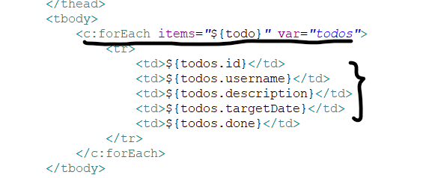

* ***Adding CSS, Bootstrap and Jquery:*** Bootstrap is a cascading style that is used to beautify HTML pages.
  + Add below dependencies for Bootstrap and Jquery and in JSP add location link to the bootstrap and jquery.
  + Before <body> tag start add:

*<link href="<location>" rel="stylesheet" >*

* + Before </body> tag end add:

*<script src="<location>"></script>*

*<script src="<location>"></script>*

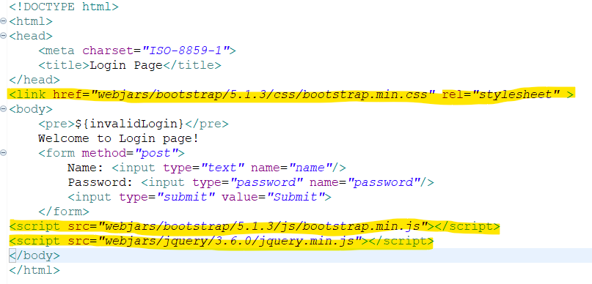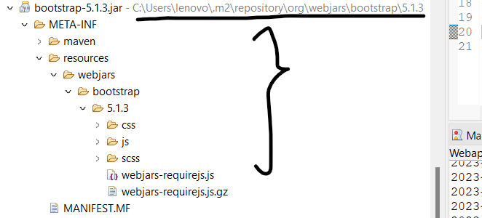

* ***Adding validations:***

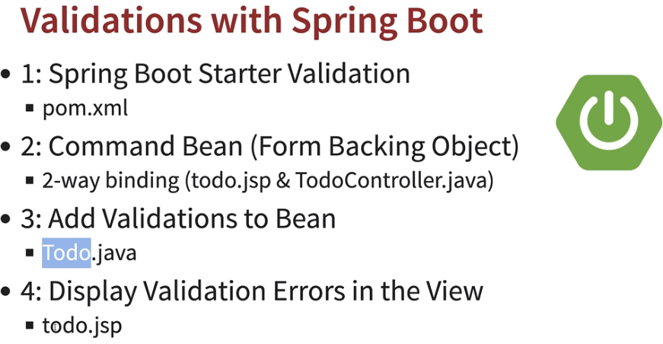

* + *Spring Boot starter validation:* It is used for server side validation.
    - Add below dependency in pom.xml.

*<dependency>*

*<groupId>org.springframework.boot</groupId>*

*<artifactId>spring-boot-starter-validation</artifactId>*

*</dependency>*

* + *Command Bean:* It is a way of binding your JSP and Controller to bean for validation using Bean.
    - In case we need to bind multiple parameters, it is not efficient to use *@RequestParam* in that case we can directly bind to model class. In order to use the form backing object in JSP we can use Spring tag libraries, which makes it easy for JSP to maintain.
    - In JSP add *ModelAttribute=”<bean>”*, getvariable by *path=”var_name”.*

*<%@ taglib prefix="form" uri="http://www.springframework.org/tags/form" %>*

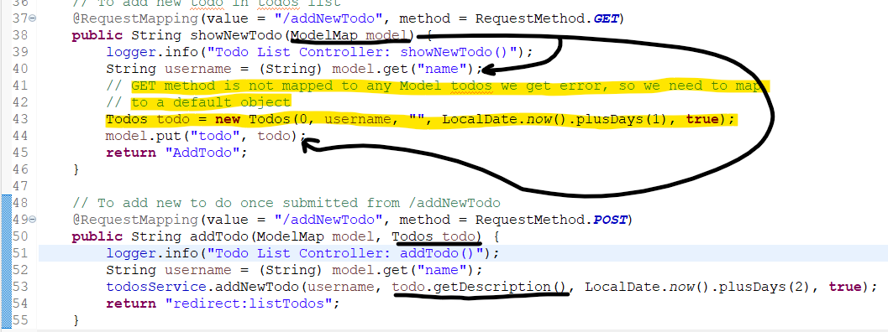

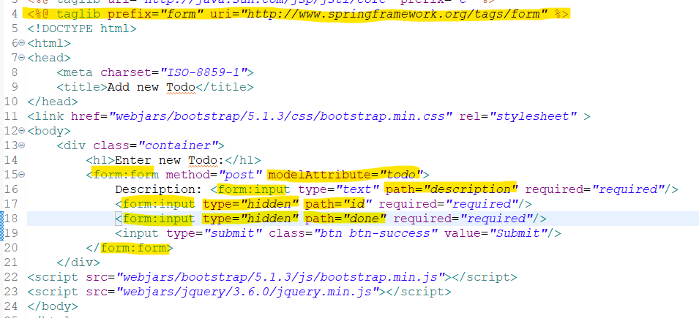

* *2 Way Binding in Command Bean:* In the below example if we see, there’s a 2 way binding, One for GET request to controller and other from POST request to controller.
* *@ModelAttribute* can be used to expose command objects to a web view, using specific attribute names, by annotating corresponding parameters of a *@RequestMapping* method.

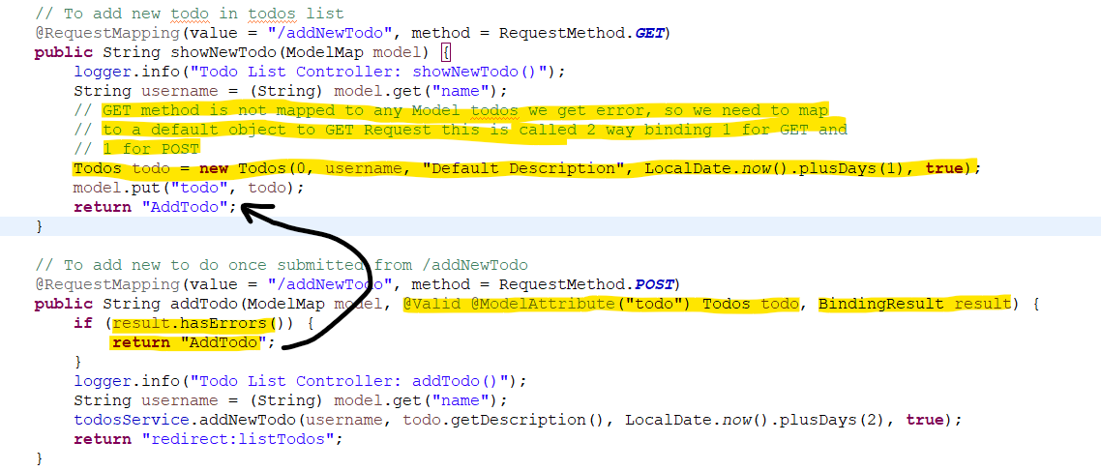

* + *Add Validations to bean: Jakarta API* provides number of bean validations, like Size, present or not, future date etc. Once these validations added in bean we need to add *@Valid @ModelAttribute(“<bean>”) <Bean> <objName>, BindingResult result* in controller method.
    - *@Valid:* This annotation ensures the validation of the whole object.
    - *BindingResult result:* It holds the result of a validation and binding and contains errors that may have occurred.

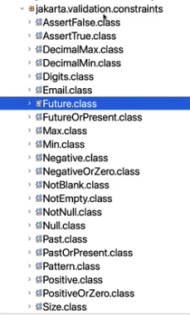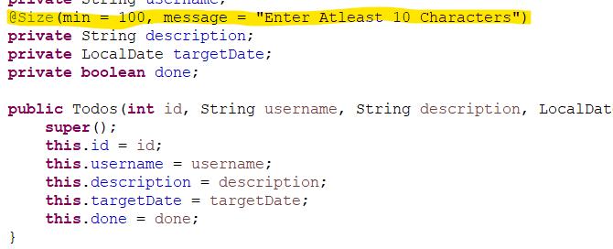

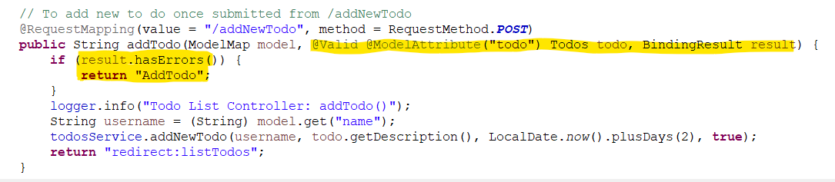

* ***Date Picker:*** Formatting date picker in whole spring MVC. *spring.mvc.format.date=yyyy-MM-dd.*
  + Add below dependency to enable bootstrap date-picker*.*

*<dependency>*

*<groupId>org.webjars</groupId>*

*<artifactId>bootstrap-datepicker</artifactId>*

*<version>1.9.0</version>*

*</dependency>*

* + Add this in JSP to enable date picker CSS and JS file.

*<link href="webjars/bootstrap-datepicker/1.9.0/css/bootstrap-datepicker.standalone.min.css" rel="stylesheet" >*

*<script src="webjars/bootstrap-datepicker/1.9.0/js/bootstrap-datepicker.min.js"></script>*

*<script type="text/javascript">*

*$('#targetDate').datepicker({*

*format: 'yyyy-mm-dd'*

*});*

*</script>*

* ***JSP Fragments:*** JSP fragments are used to refactor your JSP code, so a common code can be used in between all JSPs. It makes it easy for JSP to look more clean and maintainable.
  + Create a file *<file>.jspf* in common folder.

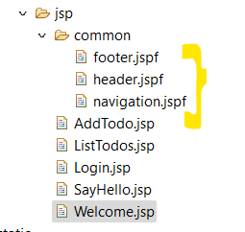

* + Import them in JSP by *<%@ include file="<location>/<file>.jspf" %>.*

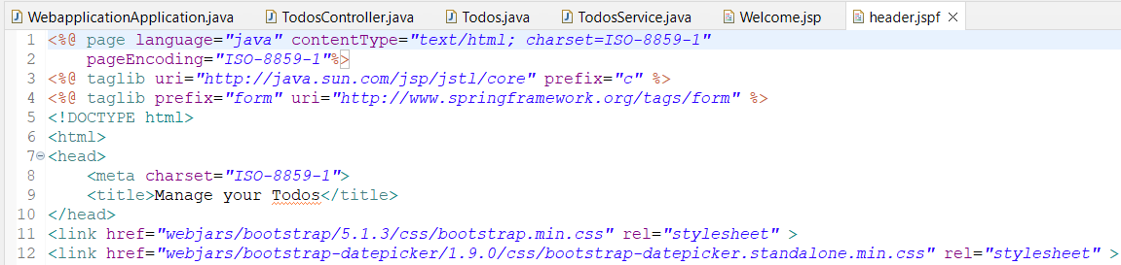

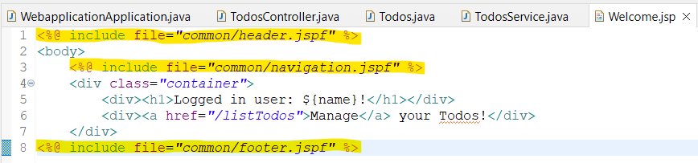

* ***Spring Boot Security:*** Spring Boot application automatically requires the Basic Authentication for all HTTP Endpoints. The Endpoint “/” and “/home” does not require any authentication. All other Endpoints require authentication. Add the following dependency in pom.xml to enable spring security. It generates a new password everytime we restart application.

*<dependency>*

*<groupId>org.springframework.boot</groupId>*

*<artifactId>spring-boot-starter-security</artifactId>*

*</dependency>*

**

* *InMemoryUserDetailsManager internally store and retrieve the user-related information which is required for Authentication. So whenever the user requests for any details, the request is filtered and passed to AuthenticationManager, which tries to authenticate the request by the using UserDetailsService.* *Once the UserDetails is loaded via InMemoryUserDetailsManager and the authentication is successful.*

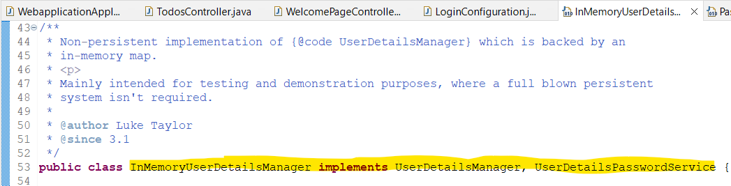

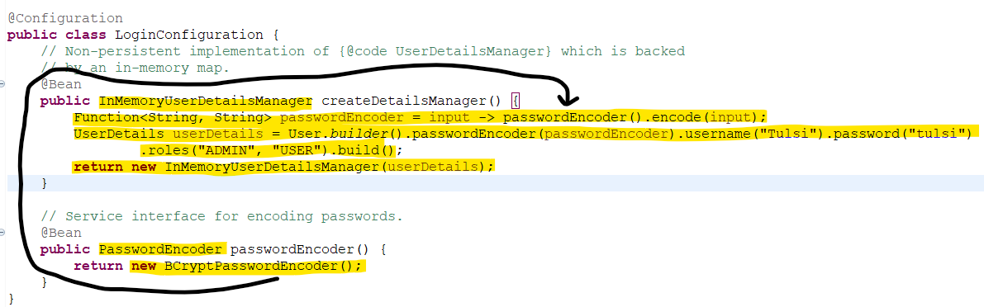

* *Get logged in User Name:*

**

* *Adding security caused an issue, right now since Spring security is activated. Every url is getting redirected to login form if not signed in. But when we try to login to JDBC H2 console, there is a challenge is user is someone else than existing user, it will not login. To address this we need to disable CSRF.*

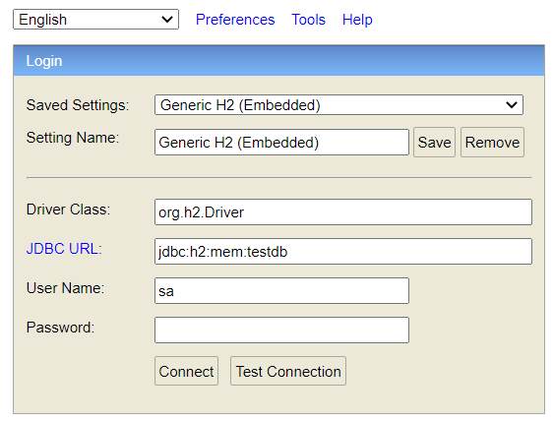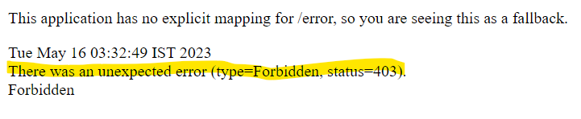

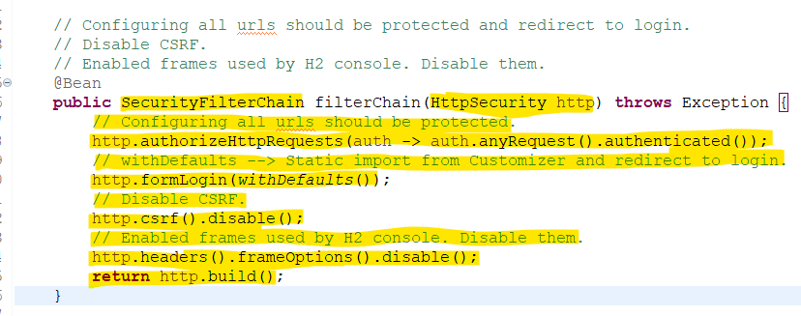

* ***@Entity:*** This annotation is used to map your model or java object with the tables at application start. By default *@Entity* creates table with class name in H2 database. In order to pre load some data in H2 database, we need to create a *SQL file* in *src/main/resources* and add below property in *application.properties.*

*spring.jpa.defer-datasource-initialization=true*

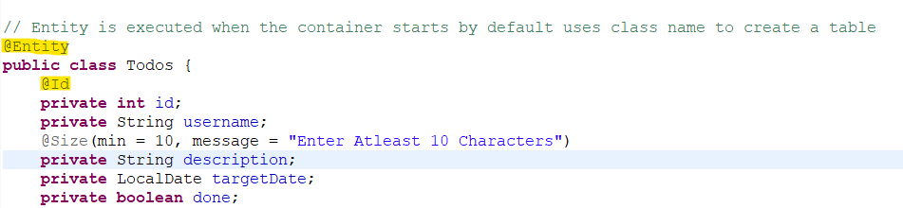

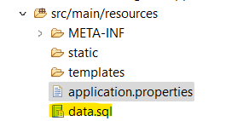

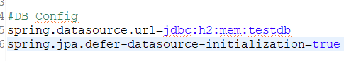

* **Launch MySQL using Docker**



***RESTApi***

* ***@GetMapping****:* In *@RequestMapping* we need to specify the *RequestMethod.GET* for handling GET requests for a url but using *@GetMapping* we need not to specify the request method. It retrieves the resource.

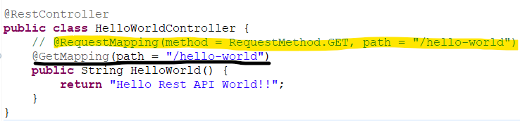

* ***DispatcherServlet****:* All requests coming to Spring boot application is handled by Dispatcher Servlet. Dispatcher Servlet acts as front controller to all request incoming and is mapped to default url ‘/’. It looks for url and maps to correct controller based upon request.
* ***@ResponseBody+JackSonHttpMessageConverters:*** If we return a bean from the controller as response then it is converted to JSON by *JackSonHttpMessageConverters. @ResponseBody* is present with *@RestController* tells a controller that the object returned is automatically serialized into JSON and passed back into the HttpResponse object.
* ***ErrorMvcAutoConfiguration:***Spring boot has one feature called auto configuration, which means based upon the required things in classpath it will automap the required dependencies. *ErrorMvcAutoConfiguration* handles all default error like hitting wrong url etc.
* *All jars available as a part of Spring Starter project which then auto configures dependencies based upon classpath added requirements.*

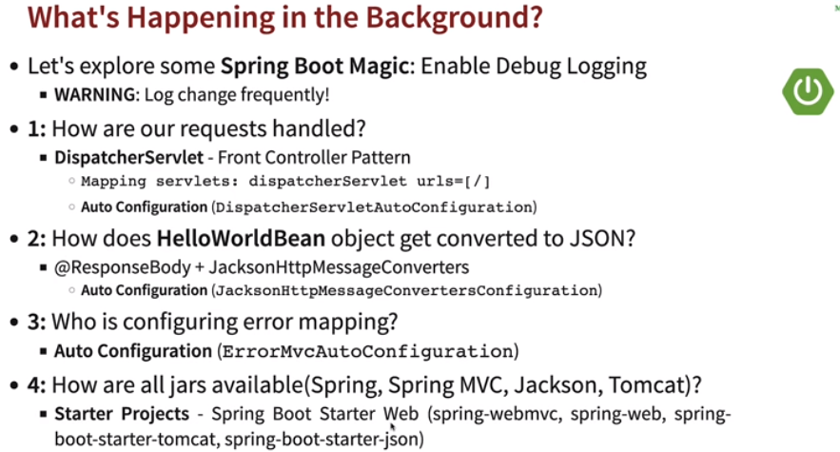

* ***@PathVariable:*** Whenever we pass a variable in url, is PathVariable. We can bind the url variables using *@PathVariable <Type> {<var>}* and return back*.* 
  + *@RequestParam* is used to capture query parameters or form parameters from the URL, whereas *@PathVariable* is used to capture values from the URL path.

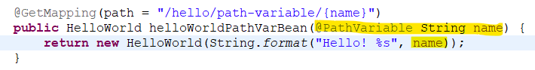

* ***HTTP Request Methods:***

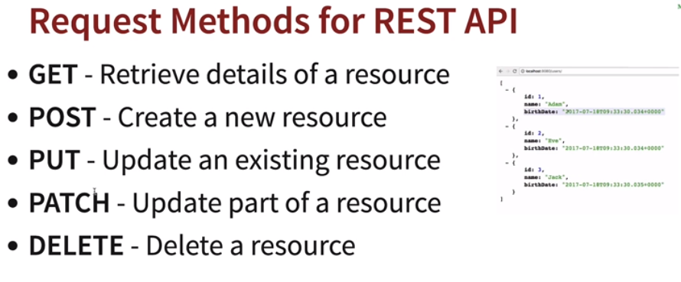

* ***DAO:*** Data Access Object. It is a class used to perform operations on Database.
* ***@RequestBody:*** *@RequestBody* annotation will get Http Request body values mapped with the model or java object.
  + *@RequestBody* annotation you will get your values mapped with the model you created in your system for handling any specific call. While by using *@ResponseBody* you can send anything back to the place from where the request was generated.
* ***HTTP Status Code:*** In controller we can *ResponseEntity* class to return correct HTTP status code.

*1) 200 — Success*

*2) 201 — Created*

*3) 204 — No Content*

*4) 401 — Unauthorized (when authorization fails)*

*5) 400 — Bad Request (such as validation error)*

*6) 404 — Resource Not Found*

*7) 500 — Server Error*

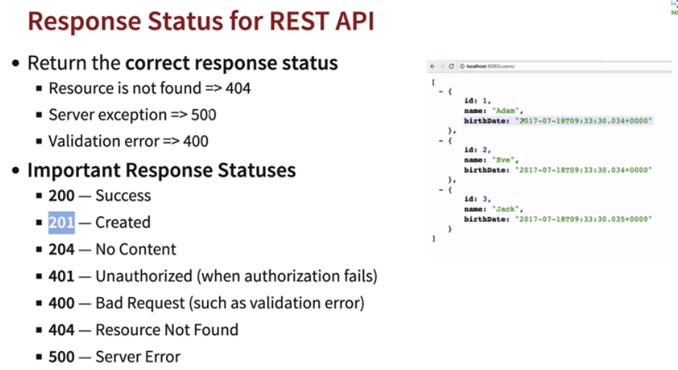

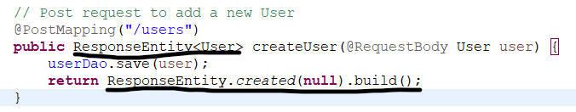

* ***Location URI:*** When we create a new resource, we would like to return the url to which the resource has been created. In that case we can location. For ex:

(Location of new User added at /users/{id})

*URI location = ServletUriComponentsBuilder* (to create links based on the current HttpServletRequest)*.fromCurrentRequest()* (from current url /users)

*.path("/{id}")* (append new id created value at the current url)

*.buildAndExpand(savedUser.getId())* (to get new users id added)

.toUri(); (convert to uri)

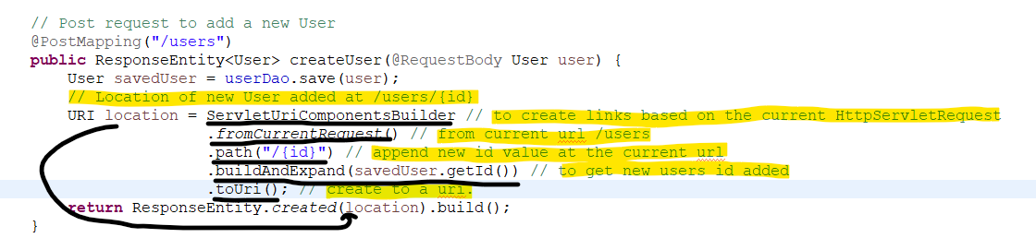

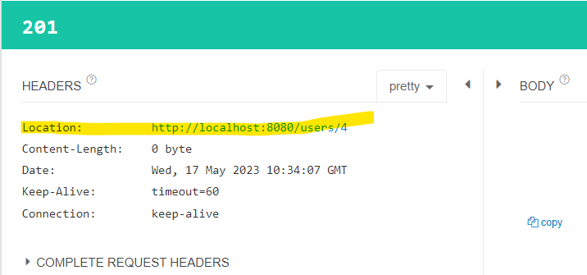

* ***ExceptionHandling:*** 
  + Create a new ExceptionClass and extends with RuntimeException and pass the message to new ExceptionClass.
  + ***@ResponseStatus(code=HttpStatus.”<method>”)*** to return a particular http response code.

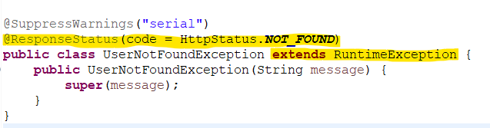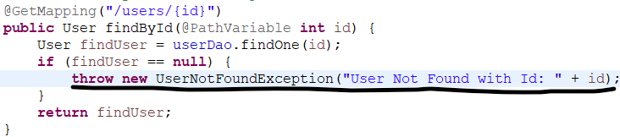

* ***Generic Exception Handling:*** In case we need to send a customize exception, we can have class extends *ResponseEntityExceptionHandler* and implement its method *handleException (Exception ex, WebRequest request) throws Exception* and return object in the form of *ResponseEntity<”Error.class”>(<err_obj>, HttpStatus.<code>);*

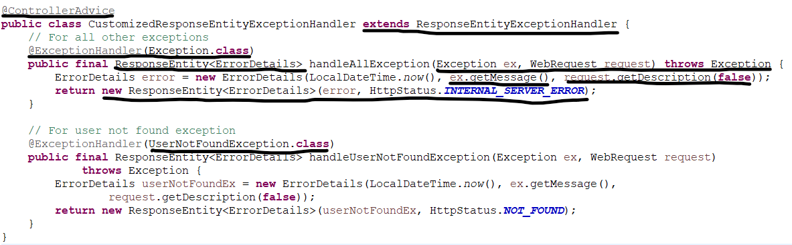

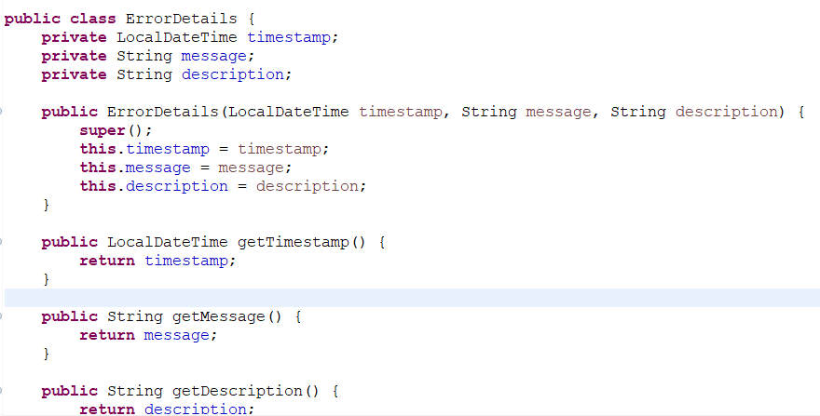

* ***@ControllerAdvice:*** Itis a specialized form of the *@Component* which allows handling exceptions across the whole application in one global handling component.
* ***@ExceptionHandler:*** It is an annotation used to handle the specific exceptions and sending the custom responses to the client.
* ***DevTools*** will not be enabled even if it is in pom.xml once application is converted to JAR file.
* ***Validating API requests:*** In order to add checks for request incoming valid or not we need to add dependency in the pom.xml.

*<dependency>*

*<groupId>org.springframework.boot</groupId>*

*<artifactId>spring-boot-starter-validation</artifactId>*

*</dependency>*

* ***@Valid:*** This annotation is used to validate the model or Java object mapped with the request incoming specified in the controller.

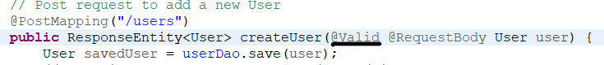

* Add validations in the Java object or model and available in the *jakarta.validation-api.constraints* jar.

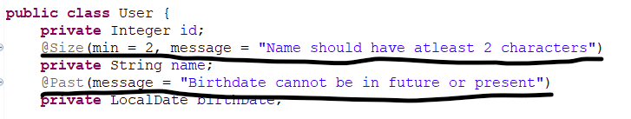

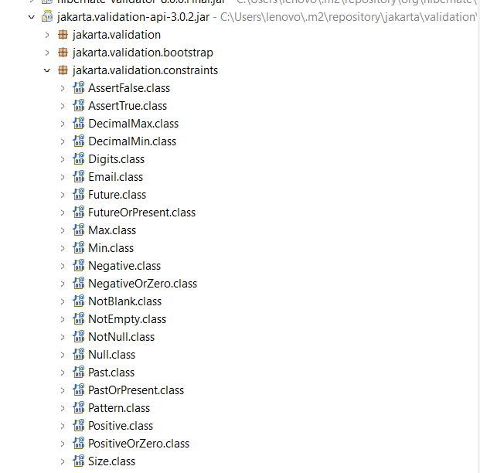

* In exception class we can override method *handleMethodArgumentNotValid* in the *ResponseEntityExceptionHandler*.

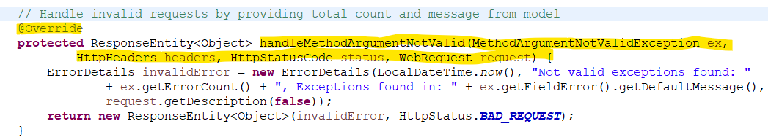

* ***API Documentation:*** API documentation is a technical content deliverable, containing instructions about how to effectively use and integrate with an API. It’s a concise reference manual containing all the information required to work with the API, with details about the functions, classes, return types, arguments and more, supported by tutorials and examples.
  + Swagger came in 2011 for API documentation, Open API is a specification created based on Swagger specification.
  + Swagger UI provides to visualize components and paths for API.
  + doc-api helps to provide complete mapping details.
  + *springdoc-openapi* java library helps to automate the generation of API documentation for spring boot projects. Add the following dependency:

*<dependency>*

*<groupId>org.springdoc</groupId>*

*<artifactId>springdoc-openapi-starter-webmvc-ui</artifactId>*

*<version>{version}</version>*

*</dependency>*

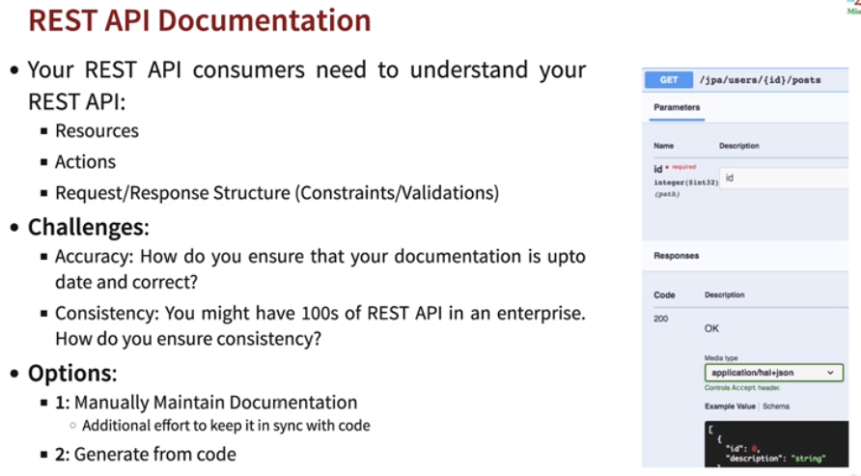

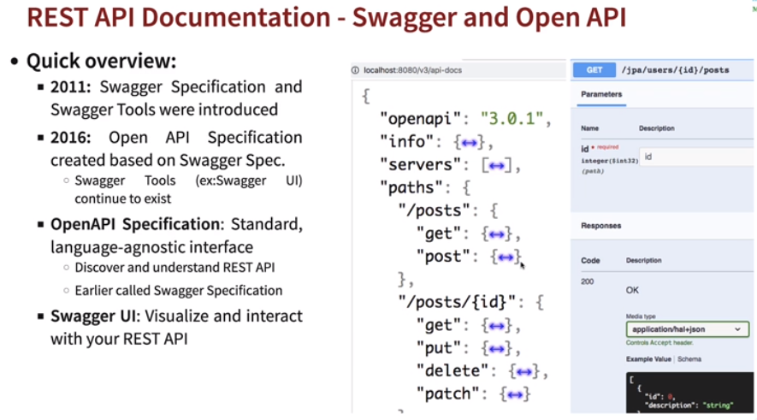

* ***Swagger UI link:*** [*http://localhost:<port>/swagger-ui/index.html*](http://localhost:%3cport%3e/swagger-ui/index.html)
* ***API-doc link:*** [*http://localhost:<port>/v3/api-docs*](http://localhost:%3cport%3e/v3/api-docs)

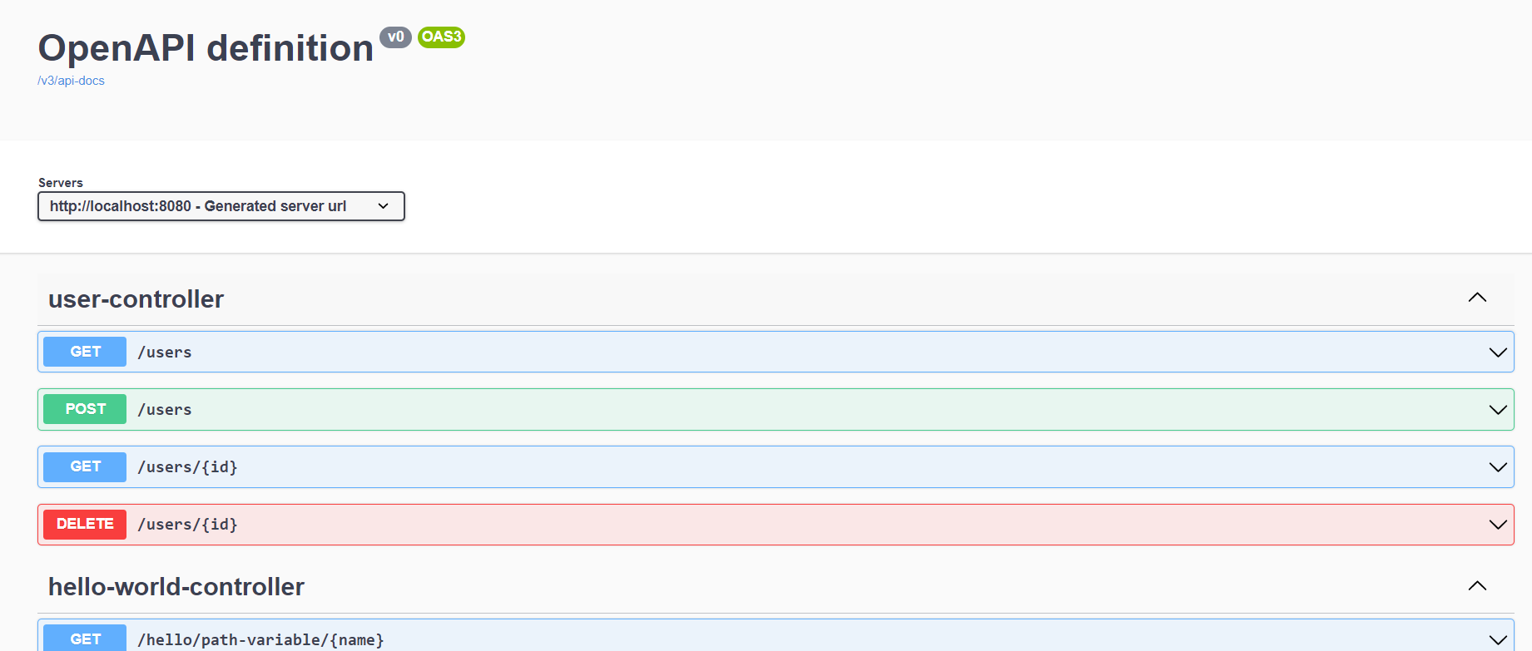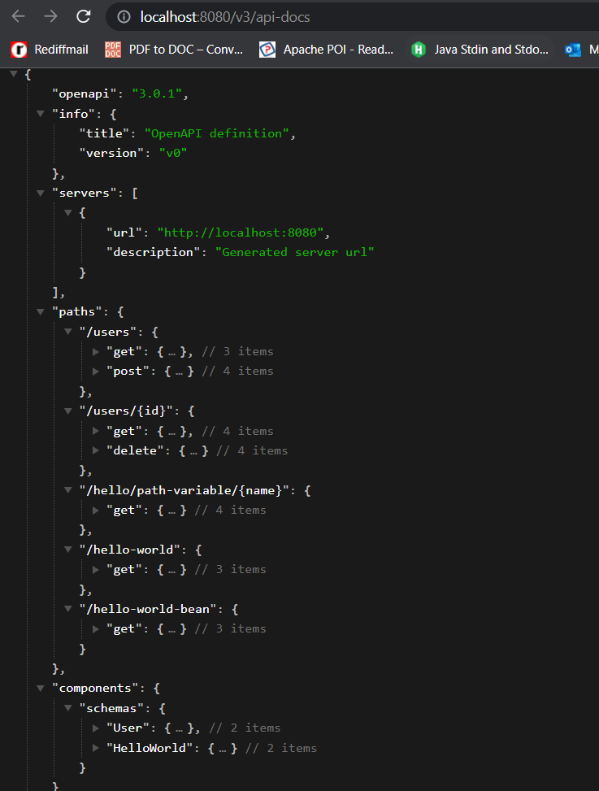

* ***Content Negotiation:*** For the same resource or URI, the consumer and service provider negotiate. In content negotiation consumer asks service provider like what type of representation they need, it could be media type like XML, JSON etc or any language like English, Dutch, French etc. Add below dependency for XML formatting.

*<dependency>*

*<groupId>com.fasterxml.jackson.dataformat</groupId>*

*<artifactId>jackson-dataformat-xml</artifactId>*

*</dependency>*

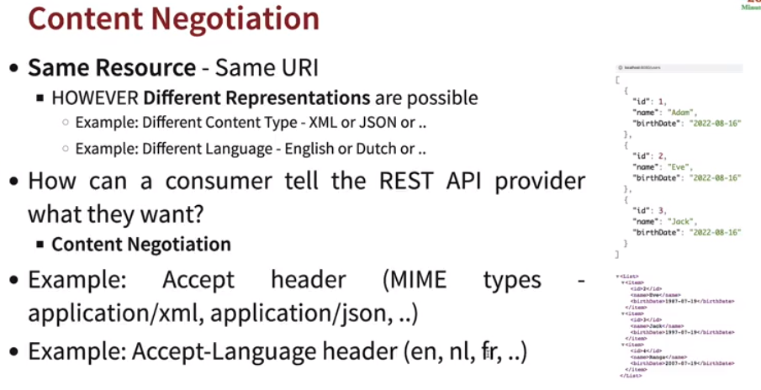

* + After adding dependency all consumer needs to send *Accept Header* as *application/xml* for *XML format* and *application/json* for *JSON format.*

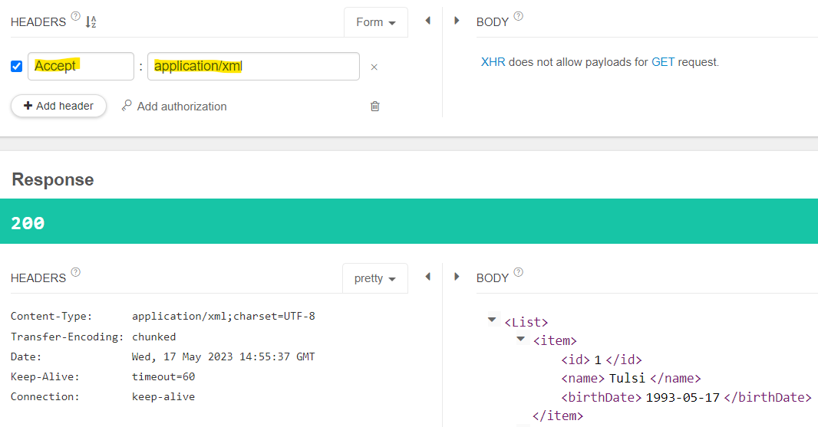

* ***Internalization(i18n):*** In case we need to show messages in different languages we can use *Internalization*.

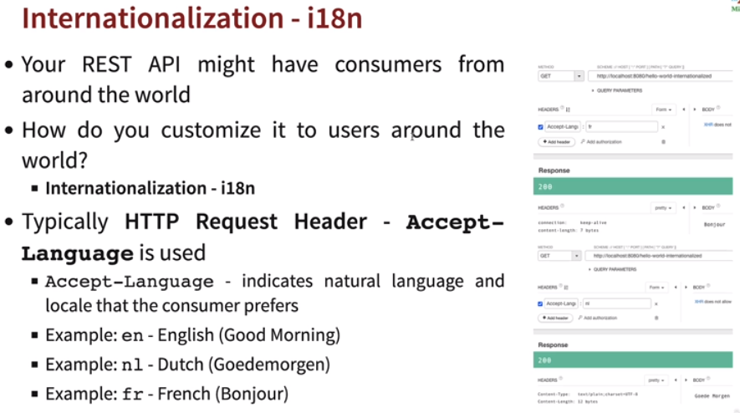

* + We need to create different *messages.properties, messages_nl.properties, messages_fr.properties etc* for different languages in *src/main/resources*.
  + Spring boot provides *MessageSource* class which picks up messages from these properties file defined in *src/main/resources*.
  + *Locale* is passed in as request with *Accept-Languages: en, fr, nl etc* as headers which then accepted by controller and redirects to correct properties file.
  + *messageSource.getMessage*(*"<properties_name>","<replacing_value>","<Default_Msg>","<locale>");*

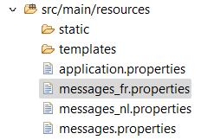 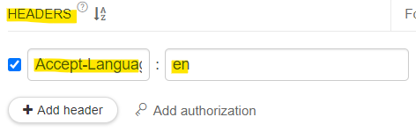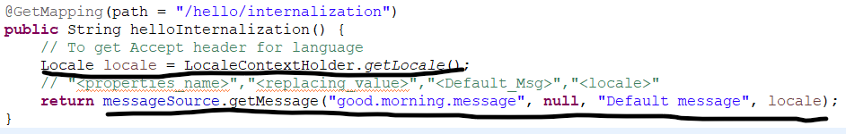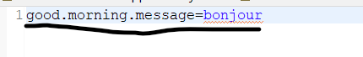

* ***Versioning:*** Let’s assume we have 2 different consumers, one accepts Name as full name and other as Name(FirstName, FullName) then in that case we need to version our API.

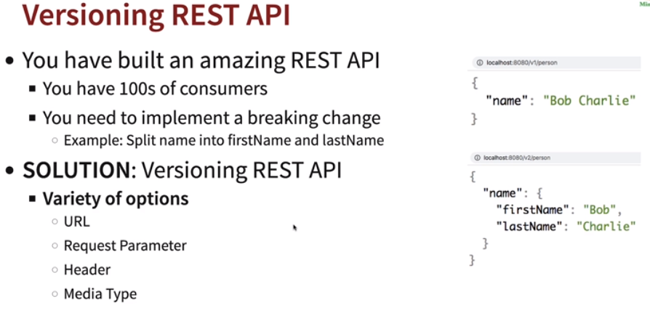

* + ***URL:*** You can create different url by *v1/v2/etc* in your endpoint to segregate versions.
    - *@GetMapping(“/<v1>/url”)*



* + ***Request Parameter:*** By passing a parameter in url to segregate versions.
    - *@GetMapping(path=“/url”, params=”<v1>”)*



* + ***Header:***By passing a custom header to segregate versions.
    - *@GetMapping(path=”/url”, headers=”/<custom_header>”)*

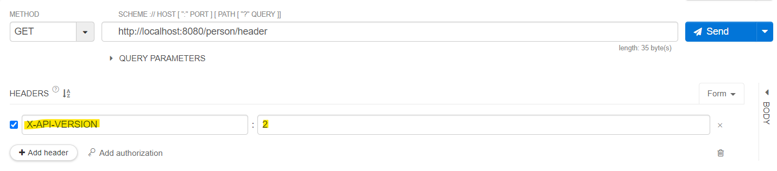

* + ***Mediatype:*** By passing Accept header in url to segregate versions.
    - *@GetMapping(path=”/url”, produces=”/<application/<custom_url>>”)*

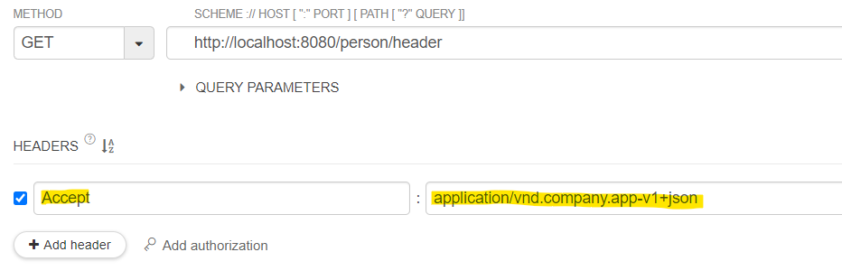

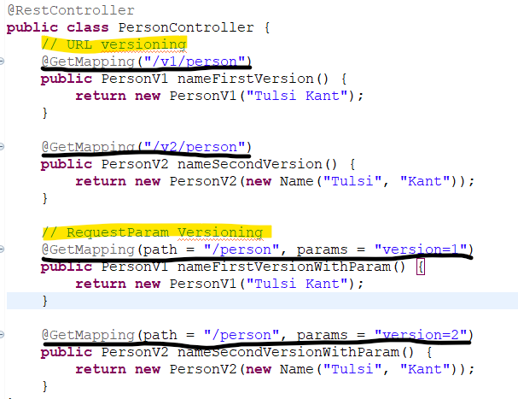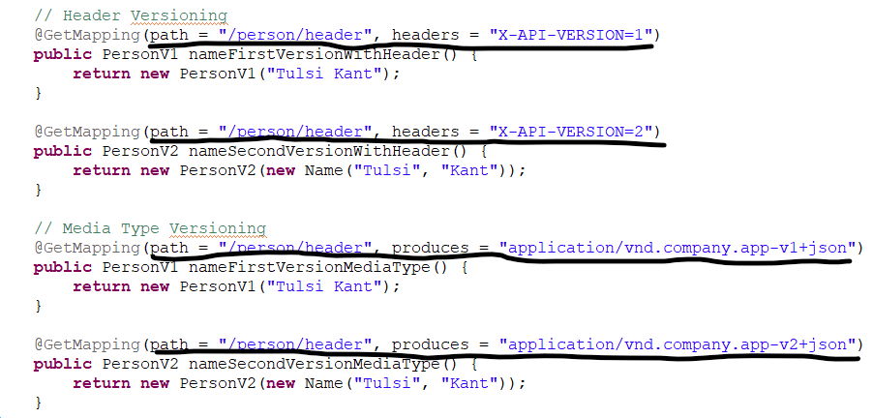

* ***Which versioning should we use?***
  + When it comes to versioning of APIs there is no perfect solution, URL and Request creates URI pollution, but caching and API documentation is easy.
  + On the other hand Headers and Mediatype it doesn’t do URI pollution but caching and API documentation is not that easy plus we can’t directly hit the url and see the response, we need to use RESTApi client or command utility.

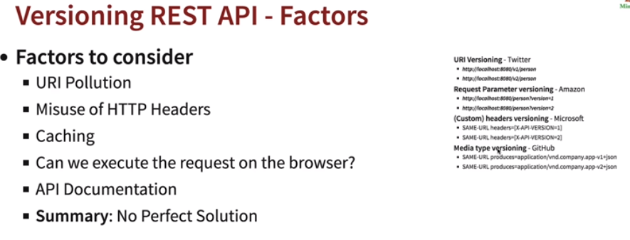

* ***HATEOAS:*** Hypermedia As The Engine Of Application State. It is used to enhance the API for consumer and add links to other methods in responses. HATEOAS, a client interacts with a network application whose application servers provide information dynamically through hypermedia. Add below dependency.

*<dependency>*

*<groupId>org.springframework.boot</groupId>*

*<artifactId>spring-boot-starter-hateoas</artifactId>*

*</dependency>*

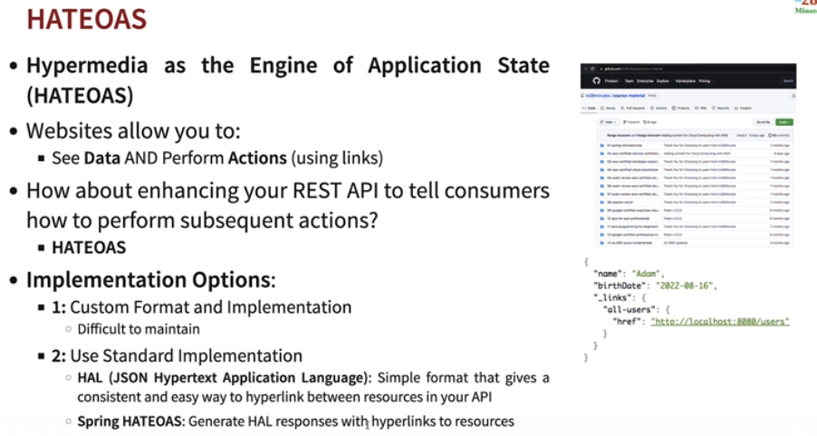

* + ***EntityModel:*** As part of adding let’s say link in our response, we don’t want to make changes in the model or Java objects so we wrap our model around *EntityModel* and add links to it.
  + ***WebMvcBuilder:*** It is used to create or add links to the EntityModel object or acts as a link builder.

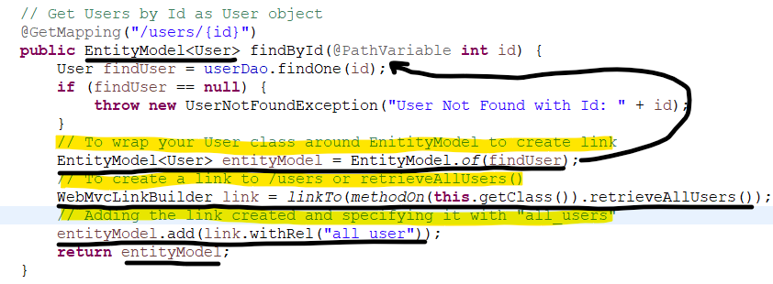

* ***Serialization:*** Convert object to stream. Ex: converting model class to JSON using Jackson.

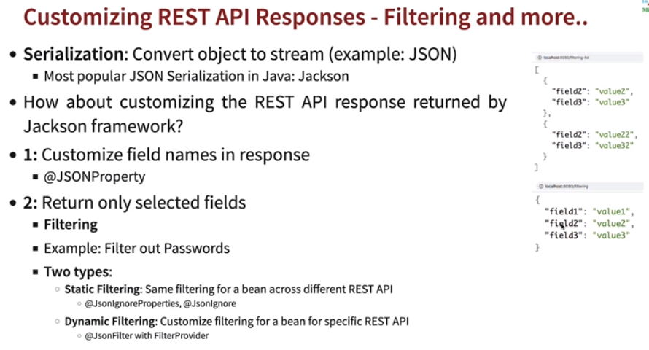

* ***@JsonProperty:*** This annotation is used to provide a custom name to model fields in the response.

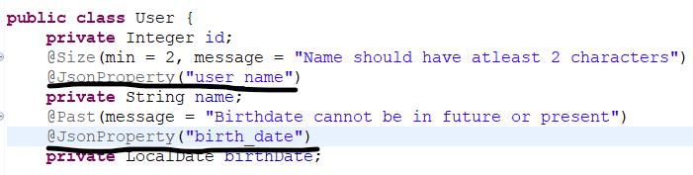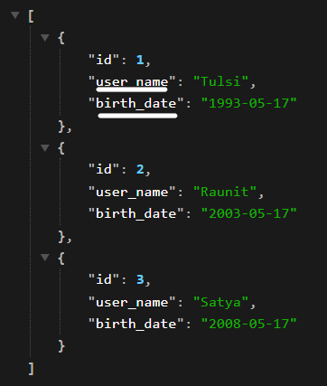

* ***Filtering:*** Let’s assume we have a bean in which we don’t want to show some fields as parameters we can use filters.
  + ***Static Filtering:*** *@JsonIgnoreProperties and @JsonIgnore* for all urls using same model.

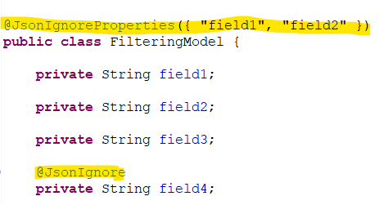 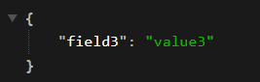

* + ***Dynamic Filtering:*** *@JsonFilter(“<filterName>”)* is used when we need to filter fields in controller instead in the models. So we can decide which url or method will show which fields using same model.

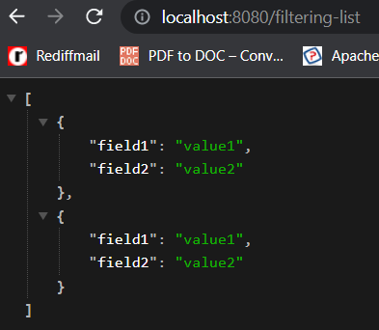 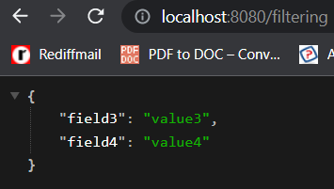

* + **MappingJacksonValue:** A simple holder for the POJO to serialize model class.
  + **SimpleBeanPropertyFilter:** Implementation that only uses property name to determine whether to serialize property as is, or to filter it out.
  + **BeanPropertyFilter:** Matches with given ids in model *@JsonFilter(<>)*.
  + In below code we first serialized our model using *MappingJacksonValue* and passing our model object in *MappingJacksonValue* object. Once serialized we need to filter out which property to leave as it is using *SimpleBeanPropertyFilter* and using its method *.filterOutAllExcept(“<fields>”).* After that we created *FilterProvider* and in it using *SimpleBeanPropertyFilter* to match *@JsonFilter(<filter_name>)* in the model. Once filter is done, we set it to serialized *JacksonMappingValue* and *setFilters(<filter>)* and returned it back as response.

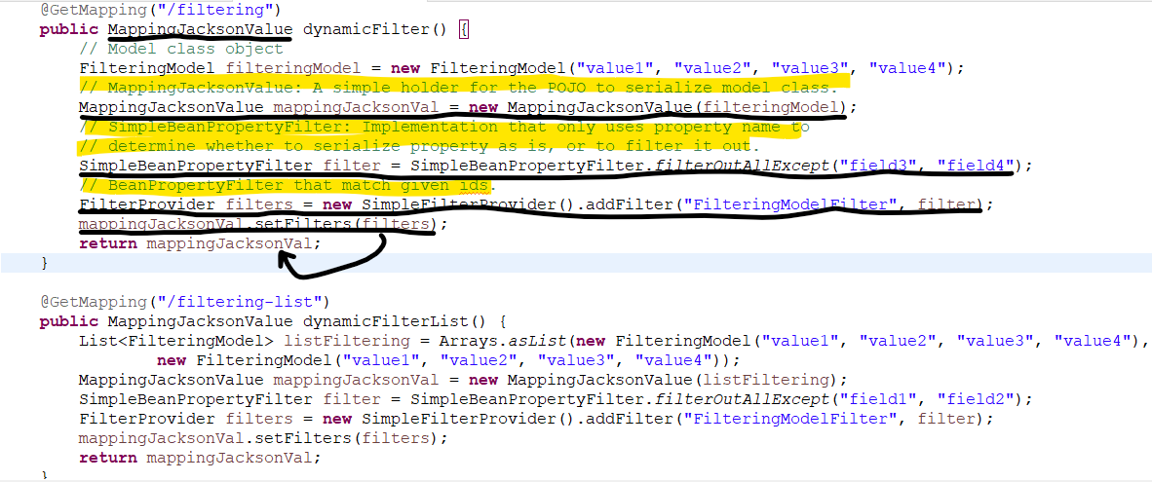

* **Spring boot Actuator:** Spring boot actuator helps in monitoring and managing your application and it provides number of endpoints, which include beans list, health information, application metrics and request mappings. To enable actuator we need to add a dependency in pom.xml.

*<dependency>*

*<groupId>org.springframework.boot</groupId>*

*<artifactId>spring-boot-starter-actuator</artifactId>*

*</dependency>*

* **Link to get actuator:** *http://<host>:<port>/actuator*





**#Enable Metrics from Spring Boot Actuator in application.properties**

*management.endpoints.web.exposure.include=* (Enables all endpts)*

*management.endpoints.web.exposure.include=health,metrics (Only specific endpts)*

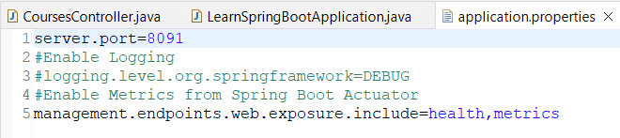

* ***HAL Explorer:*** The HAL Browser is a Javascript REST client that allows you to navigate through HAL hypermedia responses in a way similar to following links in HTML pages in a normal web browser. Add below dependency. Url: *http://localhost:<port>*

*<dependency>*

*<groupId>org.springframework.data</groupId>*

*<artifactId>spring-data-rest-hal-explorer</artifactId>*

*</dependency>*

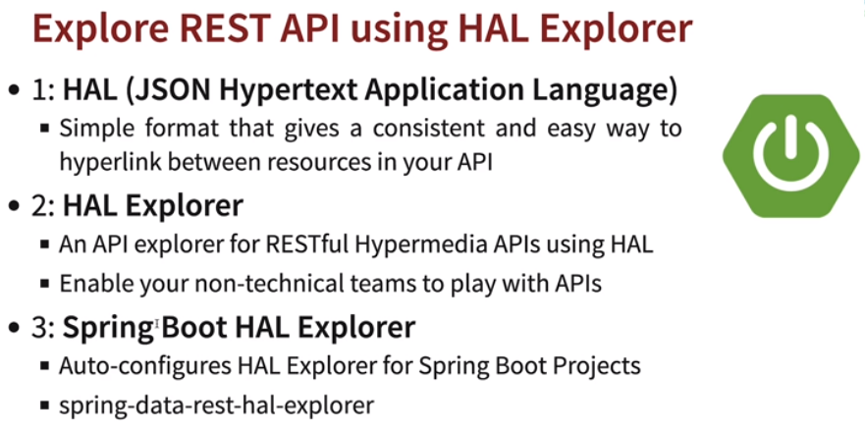

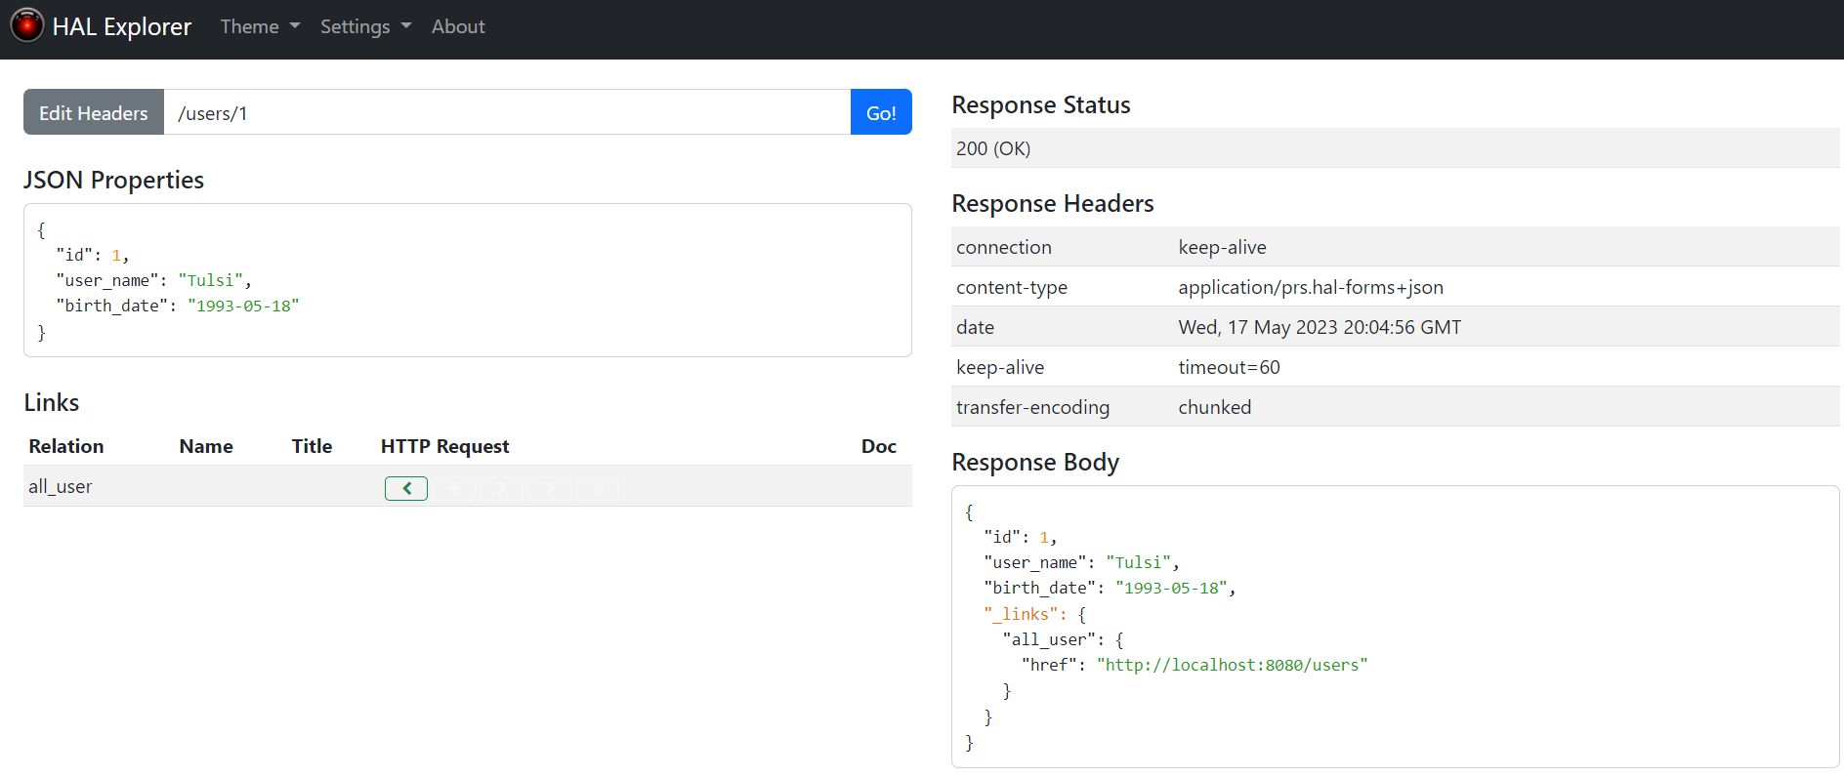

* ***@OneToMany:*** The one-to-many mapping means that one row in a table is mapped to multiple rows in another table.

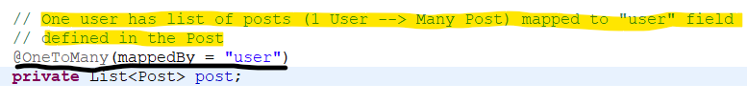

* ***@ManyToOne:*** Multiple records of a table can associate themselves with a common record in another table.
* ***FetchType:*** It is an attribute you can define in many-to-one relationship. It is *Eagerly fetched* or *Lazily fetched.* 
  + - EAGER loading of collections means that they are fetched fully at the time their parent is fetched. Default fetch type for many-to-one relationship.
    - LAZY tells Hibernate to only fetch the related entities from the database when using the relationship.

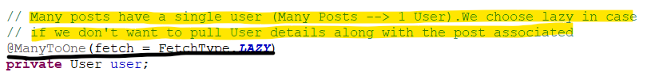

* <*File*>.sql in *src/main/resources* will be executed automatically only in H2 inbuilt memory database and not in real data base.
* ***Spring API security:*** Spring security can be enabled by adding below dependency and configure user/pass by adding properties in *application.properties.* Once added the following things, no one can access without *Authorization header* or authenticating *Login page* if directly hit url. But adding this will only allow *GET* requests to be passed even if authenticated, *PUT and POST* will still be not allowed even if authenticated due to *CSRF.*

*spring.security.user.name=<User>*

*spring.security.user.password=<Pass>*

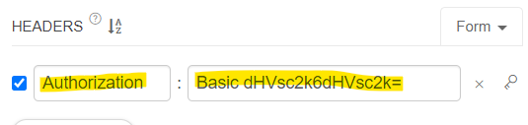

*<dependency>*

*<groupId>org.springframework.boot</groupId>*

*<artifactId>spring-boot-starter-security</artifactId>*

*</dependency>*

* ***Enhancing Security chain:*** 
  + We need to create *@Configuration class* and in that we need to annotate *@Bean* to *SecurityFilterChain interface.*
    - All requests incoming should be authenticated.

*http.authorizeHttpRequests(auth -> auth.anyRequest().authenticated());*

* + - Enable basic authorization instead of Sign In page.

*import static org.springframework.security.config.Customizer.withDefaults;*

*http.httpBasic(withDefaults());*

* + - Disable CSRF for POST and PUT requests.

*http.csrf().disable();*

